Software Requirements Specification

Eureners 3

Computer tool for measurement of the carbon footprint of food product-Oil, Cheese and Meat Transformed

Table of Contents

1 Introduction 1

1.1 Document Scope 1

1.2 Terms Glossary 1

1.3 Access control 1

1.3.1 Features Contemplated 2

2 Specific Requirements 3

2.1 Configuration and Security 3

2.1.1 Master Data 4

2.1.2 Security 32

2.1.3 Explanatory notes 43

2.2 Enterprise Data 44

2.2.1 Enterprise Data 44

2.3 Producción 47

2.3.1 Crops 48

2.3.2 Animals 61

2.3.3 Machines 66

2.3.4 Installations 69

2.3.5 Energy 71

2.3.6 Auxiliary Services 73

2.3.7 Consumables 75

2.4 Transformation 76

2.4.1 Products and Processes 77

2.4.2 Waste and Treatment 79

2.4.3 Machines 81

2.4.4 Energy 82

2.4.5 Auxiliary Services 82

2.4.6 Consumables 82

2.5 Distribution 83

2.5.1 Transport or Product distribution 83

2.5.2 Storage 84

2.5.3 Phase Use 84

2.6 Results 84

2.7 Calculating Carbon Footprint 85

2.7.1 Overall results by product 85

2.7.2 Results by Category 86

2.7.3 Results by scope 88

# Introduction

## Document Scope

This document intends to give a description of the development of the new tool "Eureners3" for calculating the carbon footprint of different final products that can be managed.

**THIS DOCUMENT IS NOT DEFINITIVE, WHICH CAN BE MODIFIED BOTH IN DEFINING TABLES AND FIELDS IN THE DATABASE, USER INTERFACE, ETC.**

**IN THE SCRIPT OF THE DATABASE DOESN'T INDICATE WHICH FIELDS ARE MANDATORY (EXCEPT THE KEYS) BECAUSE THAT CAN CHANGE, SO SHOULD BE CHECKED BY CODE.**

**BEFORE EACH** **DATABASE** **TABLE** **DEFINITION INDICATING ITS** **PHYSICAL** **NAME** **IN SPANISH.** **THE** **FIELD NAMES** **ARE GIVEN IN** **SPANISH AND** **ENGLISH** **CORRESPONDENCE** **IN PARENTHESES.**

**THE FORMULAS FOR CALCULATING THE CARBON FOOTPRINT ARE PENDING OF VALIDATION.**

## Terms Glossary

There are a number of concepts that will be repeated consistently throughout the document, therefore, is should be defined initially.

## Access control

User can enter his username and password. If the user is disabled (has down date) he can’t enter to the application.

Subsequently, the application checks to which group the user belongs, the menus that you can access and the permissions granted to the same group.

According to this control, the user will only see for the "application menu" and / or "menu options" for their role and their features and is only permitted activities previously established by the administrator (see permissions section).

The login screen will appear similar to that shown below:

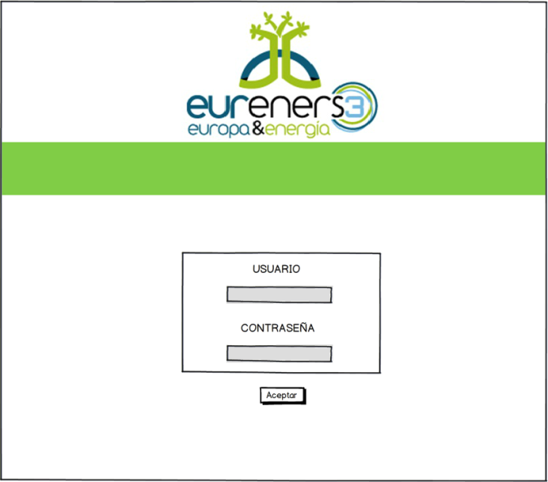

### Features Contemplated

Depending on the character of the information, type, and a number of special considerations, the application will enable the creation/modify/enable/disable/deleting data and reporting of selected data (depending on the permissions set by roles).

# Specific Requirements

## Configuration and Security

By this way is called the only menu that will only be accessed by users of role "administrator".

The user with permission to work on it can both create new master data records, such modify, disable, enable them, create users with the corresponding enterprise, etc.

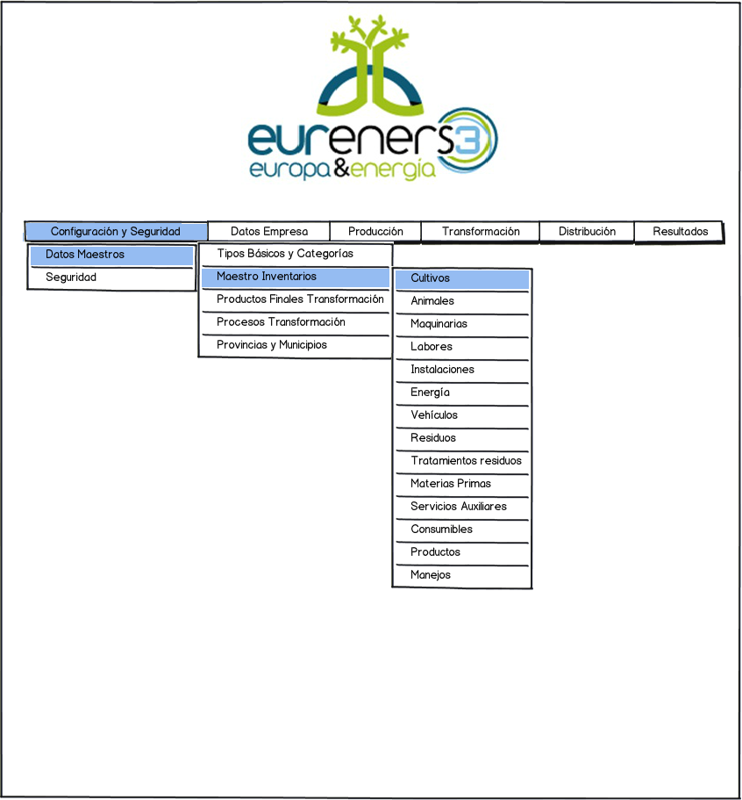

### Master Data

In this section we find the data underpinning the tool. The configuration of them is vital to the proper functioning.

#### Basic Types and Main Categories

The term basic type includes an entity that has different values associated ​​and determines the use of each in the different parts of the system. The basic types listed so far are: Crops, Animals, Installations, Machines, Transport, Products, Waste, Raw Materials, Consumables and Auxiliary Services.

The basic type Machines, includes both the elements for the production section and the transformation section.

The main categories can be retrieved from anywhere in the system, which previously has been designed for this purpose. They can’t be deleted because it will always be records associated with them. If the user wishes to stop working with them, disable the option is allowed.

Following is an approximation to the screen which will then be developed.

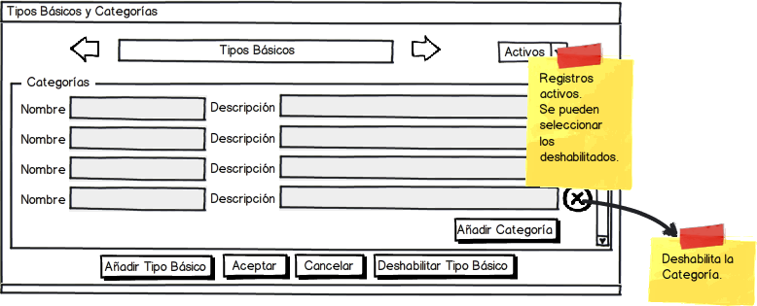

The fields in the basic Types Table (“tipos_basicos” in spanish) in database are as follows:

|  |  |  |
| --- | --- | --- |
| Name | Description | Permissions |
| Identificador (Identificator) | Automatically auto increment key, invisible to the user |  |
| Nombre (Name) | Crops, animals, etc. | Create/Modify/Delete (only on own records) |
| Fecha Baja (Down Date) | Will only have value if the record has been disabled |  |
| Usuario Creación Registro  (Creation User) | For the "Track". Invisible. | Only available for an administrator. It can be Listed. |
| Fecha Creación Registro  (Creation Date) | For the "Track". Invisible. | Only available for an administrator. It can be Listed. |
| Usuario Última Modificación (Last Modification User) | For the "Track". Invisible. | Only available for an administrator. It can be Listed. |
| Fecha Última Modificación (Last Modification Date) | For the "Track". Invisible. | Only available for an administrator. It can be Listed. |

For the categories table (“categorias” in spanish):

|  |  |  |
| --- | --- | --- |
| Name | Description | Permissions |
| Identificador (Identificator) | Automatically auto increment key, invisible to the user |  |
| Tipo Básico (Basic Type) | Relation to the type it belongs to. Invisible to the user. |  |
| Nombre (Name) | Category name. | Create/Modify/Delete (only on own records) |
| Fecha Baja (Down Date) | Will only have value if the record has been disabled |  |
| Usuario Creación Registro  (Creation User) | For the "Track". Invisible. | Only available for an administrator. It can be Listed. |
| Fecha Creación Registro  (Creation Date) | For the "Track". Invisible. | Only available for an administrator. It can be Listed. |
| Usuario Última Modificación (Last Modification User) | For the "Track". Invisible. | Only available for an administrator. It can be Listed. |
| Fecha Última Modificación (Last Modification Date) | For the "Track". Invisible. | Only available for an administrator. It can be Listed. |

#### Inventory Master

This menu option, combines many subdivisions as different types of records need to feed the tool to work.

Selecting each of these subdivisions, the admin user will access each of the properties screens where will find data that are stored in database and which the system works.

The design for any of these records is identical. At the top of the screen will display the main category and at the bottom, the various records associated with that category, with their definition fields. These records could be likened to minimum units of information, from which, the later calculations are made of carbon footprint.

On the other hand the system operation is also identical to these cases.

On the top right, you find a filter (an option down) where you can select the active records or disabled. Initially, the default corresponds to the display of records considered active.

The user can create new records associated with that category. Being able to go through all the categories considered in the system so intuitively, using icons that symbolize back arrows and advancement.

In turn, it is possible to terminate or disable a record, so fast because the right margin of each of the records (assets), there is an icon that symbolizes a cross, which when selected, it disables the corresponding record. Disable a record involves adding an expiration date in database (in the down date field).

##### ***Crops***

The screen case of properties for the crops master is as follows:

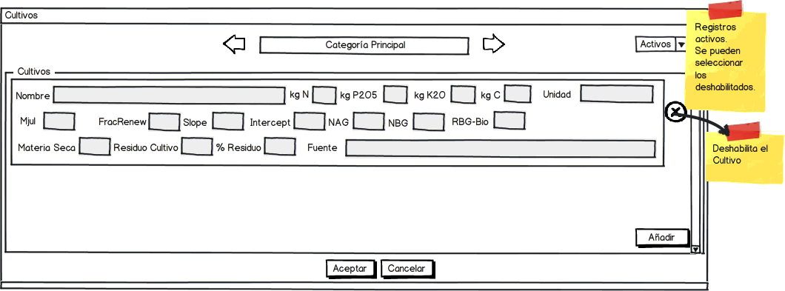

The administrator user may register, as many crops as are required for each category For example, for the category of "Fruit", the different crops that can be considered are: "Fruit", "Citrus", etc. With their corresponding values ​​and the source from which takes into account the data.

The fields in the master table for the crops are (“cultivos” in spanish):

|  |  |  |
| --- | --- | --- |
| Name | Description | Permissions |
| Identificador (Identificator) | Automatically auto increment key, invisible to the user |  |
| Tipo Básico (Basic Type) | Relation to the type it belongs to. Invisible to the user. |  |
| Categoría (Category) | Relation to the category it belongs to. Invisible to the user. |  |
| Fecha Baja (Down Date) | Will only have value if the record has been disabled |  |
| Nombre (Name) | Crop name | Create/Modify/Delete (only on own records) |
| Mjuj | Decimal Data | Create/Modify/Delete (only on own records) |
| Extracción Kg N (N Extraction) | Decimal Data | Create/Modify/Delete (only on own records) |
| Extracción Kg P (P Extraction) | Decimal Data | Create/Modify/Delete (only on own records) |
| Extracción Kg K(K Extraction) | Decimal Data | Create/Modify/Delete (only on own records) |
| Kg C | Decimal Data | Create/Modify/Delete (only on own records) |
| Unidad (Unit) | Text | Create/Modify/Delete (only on own records) |
| Fracrenew | Decimal Data | Create/Modify/Delete (only on own records) |
| Slope | Decimal Data | Create/Modify/Delete (only on own records) |
| Intercept | Decimal Data | Create/Modify/Delete (only on own records) |
| NAG | Decimal Data | Create/Modify/Delete (only on own records) |
| RBG Bio | Decimal Data | Create/Modify/Delete (only on own records) |
| Materia Seca (dry matter) | Decimal Data | Create/Modify/Delete (only on own records) |
| Residuo Cultivo (Crop Waste) | Decimal Data | Create/Modify/Delete (only on own records) |
| Porcentaje Residuo (Waste percentage) | Decimal Data | Create/Modify/Delete (only on own records) |
| Fuente (Source) | Source of data | Create/Modify/Delete (only on own records) |
| Fecha Baja (Down Date) | Will only have value if the record has been disabled |  |
| Usuario Creación Registro  (Creation User) | For the "Track". Invisible. | Only available for an administrator. It can be Listed. |
| Fecha Creación Registro  (Creation Date) | For the "Track". Invisible. | Only available for an administrator. It can be Listed. |
| Usuario Última Modificación (Last Modification User) | For the "Track". Invisible. | Only available for an administrator. It can be Listed. |
| Fecha Última Modificación (Last Modification Date) | For the "Track". Invisible. | Only available for an administrator. It can be Listed. |

##### Animals

The properties screen for the case of the master of animals:

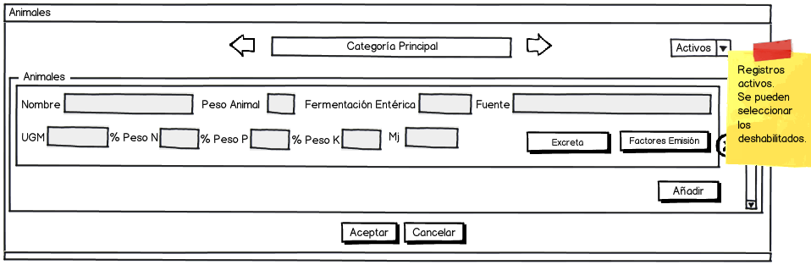

For different temperatures, the emission factors associated with each animal type:

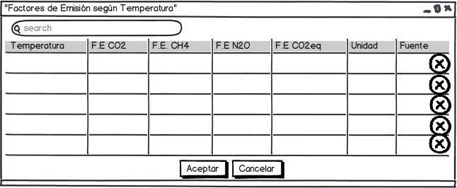

And the animals excreted by province:

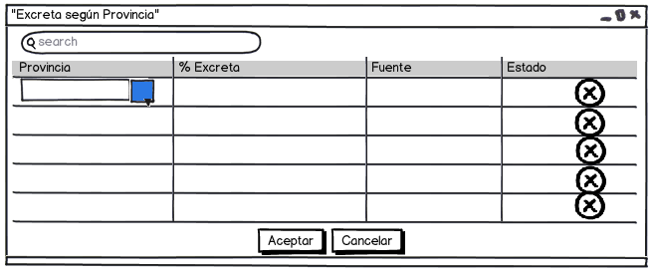

Records for the case of animals (“animales” in spanish):

|  |  |  |
| --- | --- | --- |
| Name | Description | Permissions |
| Identificador (Identificator) | Automatically auto increment key, invisible to the user |  |
| Tipo Básico (Basic Type) | Relation to the type it belongs to. Invisible to the user. |  |
| Categoría (Category) | Relation to the category it belongs to. Invisible to the user. |  |
| Nombre (Name) | Animal name | Create/Modify/Delete (only on own records) |
| UGM | Decimal Data | Create/Modify/Delete (only on own records) |
| % Peso N (N Weight Percentage) | Decimal Data | Create/Modify/Delete (only on own records) |
| % Peso P (P Weight Percentage) | Decimal Data | Create/Modify/Delete (only on own records) |
| % Peso K (K Weight Percentage) | Decimal Data | Create/Modify/Delete (only on own records) |
| Fermentación Entérica (Enteric Fermentation) | Decimal Data | Create/Modify/Delete (only on own records) |
| Peso Animal (Animal Weight) | Decimal Data | Create/Modify/Delete (only on own records) |
| Fuente (Source) | Data Source | Create/Modify/Delete (only on own records) |
| Fecha Baja (Down Date) | Will only have value if the record has been disabled |  |
| Usuario Creación Registro  (Creation User) | For the "Track". Invisible. | Only available for an administrator. It can be Listed. |
| Fecha Creación Registro  (Creation Date) | For the "Track". Invisible. | Only available for an administrator. It can be Listed. |
| Usuario Última Modificación (Last Modification User) | For the "Track". Invisible. | Only available for an administrator. It can be Listed. |
| Fecha Última Modificación (Last Modification Date) | For the "Track". Invisible. | Only available for an administrator. It can be Listed. |

For excreta according to the province (“provincias_animales_excreta” in spanish):

|  |  |  |
| --- | --- | --- |
| Name | Description | Permissions |
| Provincia (Province) | Relation to the province it belongs to. Invisible to the user. |  |
| Animal (Animal) | Relation to the animal it belongs to. Invisible to the user. |  |
| Porcentaje excreta (Excrement percentage) | Decimal Data | Create/Modify/Delete (only on own records) |
| Fuente (Source) | Text | Create/Modify/Delete (only on own records) |
| Fecha Baja (Down Date) | Will only have value if the record has been disabled |  |
| Usuario Creación Registro  (Creation User) | For the "Track". Invisible. | Only available for an administrator. It can be Listed. |
| Fecha Creación Registro  (Creation Date) | For the "Track". Invisible. | Only available for an administrator. It can be Listed. |
| Usuario Última Modificación (Last Modification User) | For the "Track". Invisible. | Only available for an administrator. It can be Listed. |
| Fecha Última Modificación (Last Modification Date) | For the "Track". Invisible. | Only available for an administrator. It can be Listed. |

And for the animal emissions according temperature (“animales_emisiones” in spanish):

|  |  |  |
| --- | --- | --- |
| Name | Description | Permissions |
| Identificador (Identificator) | Automatically auto increment key, invisible to the user |  |
| Animal (Animal) | Relation to the animal it belongs to. Invisible to the user. |  |
| Temperatura (Temperature) | Decimal Data | Create/Modify/Delete (only on own records) |
| Emisión CO2 (CO2 Emission) | Decimal data | Create/Modify/Delete (only on own records) |
| Emisión CH4 (CH4 Emission) | Decimal data | Create/Modify/Delete (only on own records) |
| Emisión N2O (NO2 Emission) | Decimal data | Create/Modify/Delete (only on own records) |
| Emisión CO2 equivalente (CO2 Equivalent Emission) | Decimal data | Create/Modify/Delete (only on own records) |
| Unidad (Unit) | Text | Create/Modify/Delete (only on own records) |
| Fuente (Source) | Text | Create/Modify/Delete (only on own records) |
| Fecha Baja (Down Date) | Will only have value if the record has been disabled |  |
| Usuario Creación Registro  (Creation User) | For the "Track". Invisible. | Only available for an administrator. It can be Listed. |
| Fecha Creación Registro  (Creation Date) | For the "Track". Invisible. | Only available for an administrator. It can be Listed. |
| Usuario Última Modificación (Last Modification User) | For the "Track". Invisible. | Only available for an administrator. It can be Listed. |
| Fecha Última Modificación (Last Modification Date) | For the "Track". Invisible. | Only available for an administrator. It can be Listed. |

##### Machines

For the case of industrial machinery:

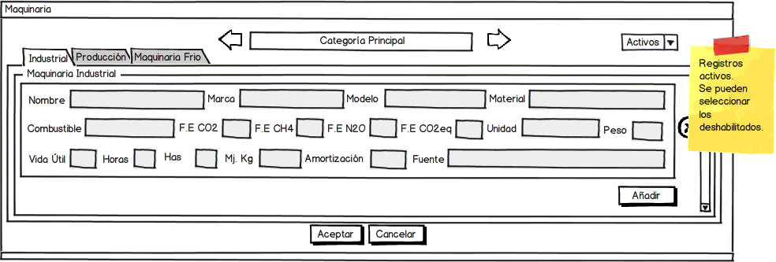

For production machinery:

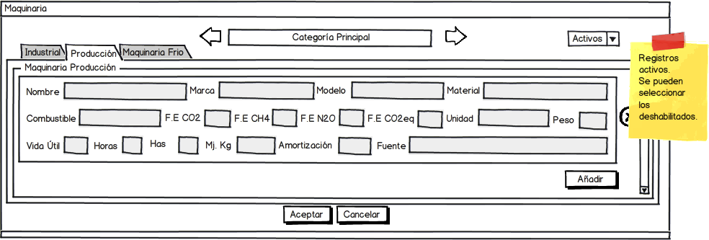

If it’s cooling machinery:

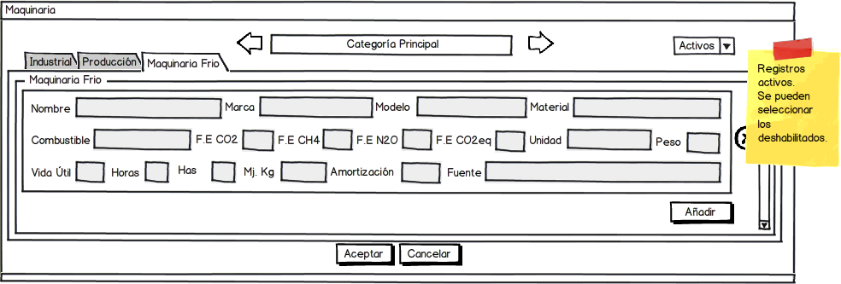

The data fields for machinery (“maquinarias” in spanish):

|  |  |  |
| --- | --- | --- |
| Name | Description | Permissions |
| Identificador (Identificator) | Automatically auto increment key, invisible to the user |  |
| Tipo Básico (Basic Type) | Relation to the type it belongs to. Invisible to the user. |  |
| Categoría (Category) | Relation to the category it belongs to. Invisible to the user. |  |
| Nombre (Name) | Machinery name | Create/Modify/Delete (only on own records) |
| Material (Material) | Machinery Material | Create/Modify/Delete (only on own records) |
| Es Vehículo Transporte (Is transport vehicle) | Indicate Yes or No, the machinery used in transport (1 if it is created through the vehicles window, 0 otherwise) | Create/Modify/Delete (only on own records) |
| Es Maquinaria Transformación (Is transformation machinery) | Indicate Yes or No, the machinery is used in processing industry (1 if it is created from the processing tab, 0 otherwise). | Create/Modify/Delete (only on own records) |
| Es Maquinaria Producción (Is production machinery) | Indicate Yes or No, the machinery is used in the production phase (1 if it is created from the production tab, 0 otherwise). | Create/Modify/Delete (only on own records) |
| Es Maquinaria Frio (Is cooling machine) | Indicate Yes or No, the machine is cooling (1 if the tab has been created from cold machinery, 0 otherwise) | Create/Modify/Delete (only on own records) |
| Marca (Trademark) | Text | Create/Modify/Delete (only on own records) |
| Modelo (Model) | Text | Create/Modify/Delete (only on own records) |
| Combustible (Fuel) | Text | Create/Modify/Delete (only on own records) |
| Peso Estándar (Standard Weight) | Decimal Data | Create/Modify/Delete (only on own records) |
| Amortización (Amortization) | Decimal Data | Create/Modify/Delete (only on own records) |
| Vida Útil (Lifetime) | Decimal Data | Create/Modify/Delete (only on own records) |
| Antigüedad (antiquity) | Decimal Data | Create/Modify/Delete (only on own records) |
| Horas (Hours) | Decimal Data | Create/Modify/Delete (only on own records) |
| Has (hectares) | Decimal Data | Create/Modify/Delete (only on own records) |
| Mj Kg (energetic value) | Decimal Data | Create/Modify/Delete (only on own records) |
| Emisión CO2 (CO2 Emission) | Decimal data | Create/Modify/Delete (only on own records) |
| Emisión CH4 (CH4 Emission) | Decimal data | Create/Modify/Delete (only on own records) |
| Emisión N2O (NO2 Emission) | Decimal data | Create/Modify/Delete (only on own records) |
| Emisión CO2 equivalente (CO2 Equivalent Emission) | Decimal data | Create/Modify/Delete (only on own records) |
| Unidad (Unit) | Text | Create/Modify/Delete (only on own records) |
| Fuente (Source) | Text | Create/Modify/Delete (only on own records) |
| Fecha Baja (Down Date) | Will only have value if the record has been disabled |  |
| Usuario Creación Registro  (Creation User) | For the "Track". Invisible. | Only available for an administrator. It can be Listed. |
| Fecha Creación Registro  (Creation Date) | For the "Track". Invisible. | Only available for an administrator. It can be Listed. |
| Usuario Última Modificación (Last Modification User) | For the "Track". Invisible. | Only available for an administrator. It can be Listed. |
| Fecha Última Modificación (Last Modification Date) | For the "Track". Invisible. | Only available for an administrator. It can be Listed. |

##### Transport Vehicles

For the case of transport vehicles, the master screen properties:

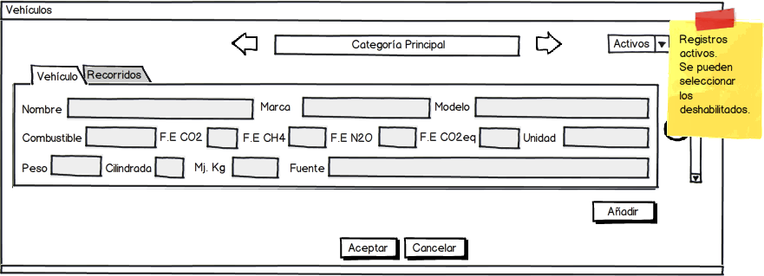

To a vehicle may be added as many paths as needed:

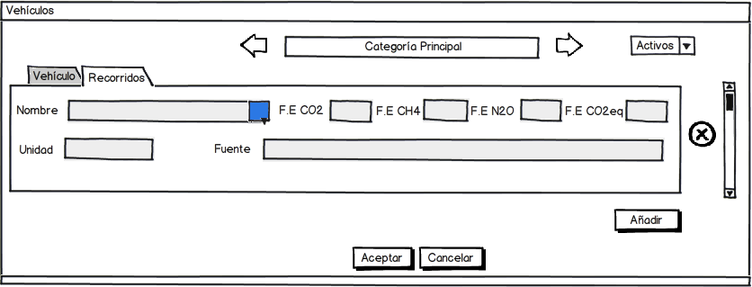

The fields for the required data, stored in the same table as the machinery (“maquinarias” in spanish):

|  |  |  |
| --- | --- | --- |
| Name | Description | Permissions |
| Identificador (Identificator) | Automatically auto increment key, invisible to the user |  |
| Tipo Básico (Basic Type) | Relation to the type it belongs to. Invisible to the user. |  |
| Categoría (Category) | Relation to the category it belongs to. Invisible to the user. |  |
| Es Vehículo Transporte (Is transport vehicle) | Indicate Yes or No, the machinery used in transport (1 if it is created through the vehicles window, 0 otherwise) | Create/Modify/Delete (only on own records) |
| Nombre (Name) | Vehicle name | Create/Modify/Delete (only on own records) |
| Marca (Trademark) | Text | Create/Modify/Delete (only on own records) |
| Modelo (Model) | Text | Create/Modify/Delete (only on own records) |
| Combustible (Fuel) | Text | Create/Modify/Delete (only on own records) |
| Peso Estándar (Standard Weight) | Decimal Data | Create/Modify/Delete (only on own records) |
| Mj Kg (energetic value) | Decimal Data | Create/Modify/Delete (only on own records) |
| Emisión CO2 (CO2 Emission) | Decimal data | Create/Modify/Delete (only on own records) |
| Emisión CH4 (CH4 Emission) | Decimal data | Create/Modify/Delete (only on own records) |
| Emisión N2O (NO2 Emission) | Decimal data | Create/Modify/Delete (only on own records) |
| Emisión CO2 equivalente (CO2 Equivalent Emission) | Decimal data | Create/Modify/Delete (only on own records) |
| Unidad (Unit) | Text | Create/Modify/Delete (only on own records) |
| Fuente (Source) | Text | Create/Modify/Delete (only on own records) |
| Fecha Baja (Down Date) | Will only have value if the record has been disabled |  |
| Usuario Creación Registro  (Creation User) | For the "Track". Invisible. | Only available for an administrator. It can be Listed. |
| Fecha Creación Registro  (Creation Date) | For the "Track". Invisible. | Only available for an administrator. It can be Listed. |
| Usuario Última Modificación (Last Modification User) | For the "Track". Invisible. | Only available for an administrator. It can be Listed. |
| Fecha Última Modificación (Last Modification Date) | For the "Track". Invisible. | Only available for an administrator. It can be Listed. |

And for routes (“recorridos” in spanish):

|  |  |  |
| --- | --- | --- |
| Name | Description | Permissions |
| Identificador (Identificator) | Automatically auto increment key, invisible to the user |  |
| Maquinaria (Machinery) | Relation to the machinery it belongs to. Invisible to the user. |  |
| Nombre (Name) | Route name | Crear/Modificar/Eliminar (solo sobre sus registros) |
| Emisión CO2 (CO2 Emission) | Decimal data | Create/Modify/Delete (only on own records) |
| Emisión CH4 (CH4 Emission) | Decimal data | Create/Modify/Delete (only on own records) |
| Emisión N2O (NO2 Emission) | Decimal data | Create/Modify/Delete (only on own records) |
| Emisión CO2 equivalente (CO2 Equivalent Emission) | Decimal data | Create/Modify/Delete (only on own records) |
| Unidad (Unit) | Text | Create/Modify/Delete (only on own records) |
| Fuente (Source) | Text | Create/Modify/Delete (only on own records) |
| Fecha Baja (Down Date) | Will only have value if the record has been disabled |  |
| Usuario Creación Registro  (Creation User) | For the "Track". Invisible. | Only available for an administrator. It can be Listed. |
| Fecha Creación Registro  (Creation Date) | For the "Track". Invisible. | Only available for an administrator. It can be Listed. |
| Usuario Última Modificación (Last Modification User) | For the "Track". Invisible. | Only available for an administrator. It can be Listed. |

##### Works

For the case of work, it is necessary to note that in most cases, to perform them, it will be necessary to associate one or more machines.

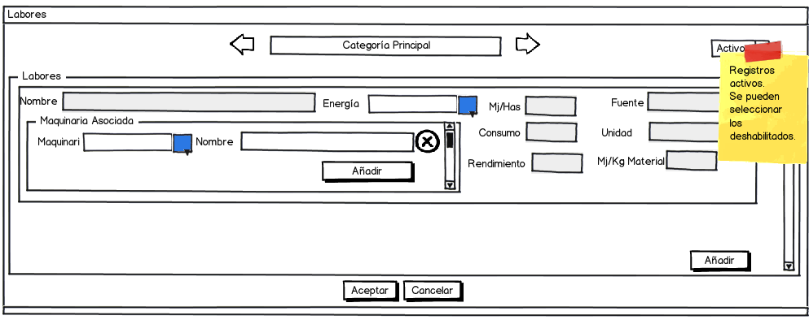

Machines can be selected among those that have been previously released such production machinery.

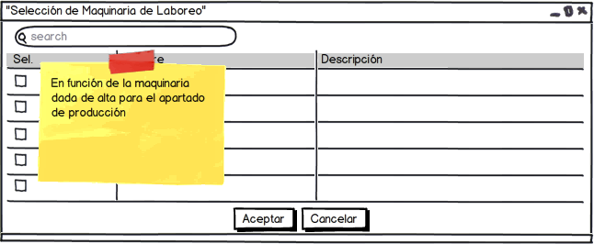

The data to be included in database, for the work (“labores” in spanish):

|  |  |  |
| --- | --- | --- |
| Name | Description | Permissions |
| Identificador (Identificator) | Automatically auto increment key, invisible to the user |  |
| Tipo Básico (Basic Type) | Relation to the type it belongs to. Invisible to the user. |  |
| Categoría (Category) | Relation to the category it belongs to. Invisible to the user. |  |
| Nombre (Name) | Work name | Create/Modify/Delete (only on own records) |
| Consumo (consumption) | Decimal Data | Create/Modify/Delete (only on own records) |
| Rendimiento (performance) | Decimal Data | Create/Modify/Delete (only on own records) |
| Mj Kg (energetic value) | Decimal Data | Create/Modify/Delete (only on own records) |
| Energía (Energy) | Relation to the energy it belongs to. Invisible to the user. | Create/Modify/Delete (only on own records) |
| Fuente (Source) | Data source | Create/Modify/Delete (only on own records) |
| Unidad (Unit) | Text | Create/Modify/Delete (only on own records) |
| Mj Kg material (material energetic value) | Decimal Data | Create/Modify/Delete (only on own records) |
| Fecha Baja (Down Date) | Will only have value if the record has been disabled |  |
| Usuario Creación Registro  (Creation User) | For the "Track". Invisible. | Only available for an administrator. It can be Listed. |
| Fecha Creación Registro  (Creation Date) | For the "Track". Invisible. | Only available for an administrator. It can be Listed. |
| Usuario Última Modificación (Last Modification User) | For the "Track". Invisible. | Only available for an administrator. It can be Listed. |
| Fecha Última Modificación (Last Modification Date) | For the "Track". Invisible. | Only available for an administrator. It can be Listed. |
| Details (“labor_maquinarias” in spanish) | | |
| Maquinaria (Machinery) | It is a relation table, ie many machines can be associated to the work, as needed. |  |

##### Installations

For the case of installations, the properties screen is the following:

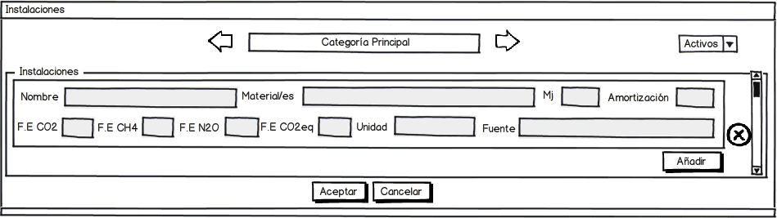

And the data to be stored in the installations master table (“instalaciones” in spanish):

|  |  |  |
| --- | --- | --- |
| Name | Description | Permissions |
| Identificador (Identificator) | Automatically auto increment key, invisible to the user |  |
| Tipo Básico (Basic Type) | Relation to the type it belongs to. Invisible to the user. |  |
| Categoría (Category) | Relation to the category it belongs to. Invisible to the user. |  |
| Nombre (Name) | Installation name | Create/Modify/Delete (only on own records) |
| Mj M2 (energetic value) | Decimal Data | Create/Modify/Delete (only on own records) |
| Material (Material) | Material/s name/s | Create/Modify/Delete (only on own records) |
| Amortización (Amortization) | Decimal Data | Create/Modify/Delete (only on own records) |
| Emisión CO2 (CO2 Emission) | Decimal data | Create/Modify/Delete (only on own records) |
| Emisión CH4 (CH4 Emission) | Decimal data | Create/Modify/Delete (only on own records) |
| Emisión N2O (NO2 Emission) | Decimal data | Create/Modify/Delete (only on own records) |
| Emisión CO2 equivalente (CO2 Equivalent Emission) | Decimal data | Create/Modify/Delete (only on own records) |
| Unidad (Unit) | Text | Create/Modify/Delete (only on own records) |
| Fuente (Source) | Text | Create/Modify/Delete (only on own records) |
| Fecha Baja (Down Date) | Will only have value if the record has been disabled |  |
| Usuario Creación Registro  (Creation User) | For the "Track". Invisible. | Only available for an administrator. It can be Listed. |
| Fecha Creación Registro  (Creation Date) | For the "Track". Invisible. | Only available for an administrator. It can be Listed. |
| Usuario Última Modificación (Last Modification User) | For the "Track". Invisible. | Only available for an administrator. It can be Listed. |
| Fecha Última Modificación (Last Modification Date) | For the "Track". Invisible. | Only available for an administrator. It can be Listed. |

##### Energy

The energy screen to the energies master:

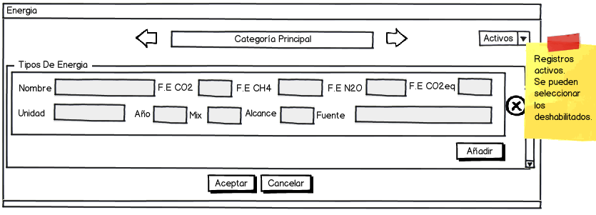

In the case of energy, the data must store the database (“energias” in spanish):

|  |  |  |
| --- | --- | --- |
| Name | Description | Permissions |
| Identificador (Identificator) | Automatically auto increment key, invisible to the user |  |
| Tipo Básico (Basic Type) | Relation to the type it belongs to. Invisible to the user. |  |
| Categoría (Category) | Relation to the category it belongs to. Invisible to the user. |  |
| Nombre (Name) | Energy name | Create/Modify/Delete (only on own records) |
| Emisión CO2 (CO2 Emission) | Decimal data | Create/Modify/Delete (only on own records) |
| Emisión CH4 (CH4 Emission) | Decimal data | Create/Modify/Delete (only on own records) |
| Emisión N2O (NO2 Emission) | Decimal data | Create/Modify/Delete (only on own records) |
| Emisión CO2 equivalente (CO2 Equivalent Emission) | Decimal data | Create/Modify/Delete (only on own records) |
| Fuente (Source) | Text | Create/Modify/Delete (only on own records) |
| Mix | Decimal Data | Create/Modify/Delete (only on own records) |
| Alcance (Scope) | Numeric Data. From 1 to 3. | Create/Modify/Delete (only on own records) |
| Unidad (Unit) | Text | Create/Modify/Delete (only on own records) |
| Year | Numeric Data | Create/Modify/Delete (only on own records) |
| Fecha Baja (Down Date) | Will only have value if the record has been disabled |  |
| Usuario Creación Registro  (Creation User) | For the "Track". Invisible. | Only available for an administrator. It can be Listed. |
| Fecha Creación Registro  (Creation Date) | For the "Track". Invisible. | Only available for an administrator. It can be Listed. |
| Usuario Última Modificación (Last Modification User) | For the "Track". Invisible. | Only available for an administrator. It can be Listed. |
| Fecha Última Modificación (Last Modification Date) | For the "Track". Invisible. | Only available for an administrator. It can be Listed. |

##### Wastes

Wastes as already mentioned above, are somewhat more complex.

On later parts of the system will also be necessary to indicate the mode of treatment thereof.

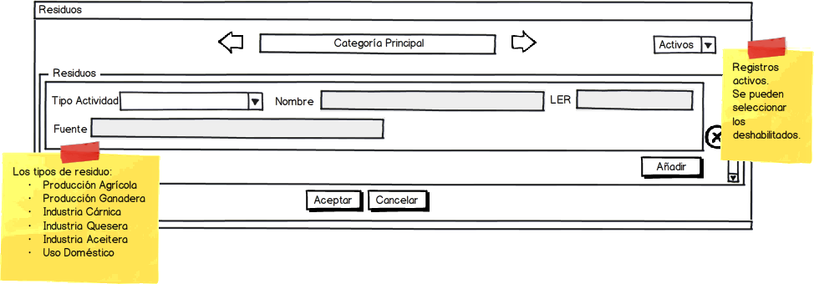

Data corresponding to wastes (“residuos” in spanish):

|  |  |  |
| --- | --- | --- |
| Name | Description | Permissions |
| Identificador (Identificator) | Automatically auto increment key, invisible to the user |  |
| Tipo Básico (Basic Type) | Relation to the type it belongs to. Invisible to the user. |  |
| Categoría (Category) | Relation to the category it belongs to. Invisible to the user. |  |
| Tipo Actividad (Activity Type) | Allowed values:  -Producción Agrícola  -Producción Ganadera  -Industria Cárnica  -Industria Quesera  -Industria Aceitera  -Uso Doméstico | Create/Modify/Delete (only on own records) |
| Nombre (Name) | Waste name | Create/Modify/Delete (only on own records) |
| LER | LER Code | Create/Modify/Delete (only on own records) |
| Fuente (Source) | Data Source | Create/Modify/Delete (only on own records) |
| Fecha Baja (Down Date) | Will only have value if the record has been disabled |  |
| Usuario Creación Registro  (Creation User) | For the "Track". Invisible. | Only available for an administrator. It can be Listed. |
| Fecha Creación Registro  (Creation Date) | For the "Track". Invisible. | Only available for an administrator. It can be Listed. |
| Usuario Última Modificación (Last Modification User) | For the "Track". Invisible. | Only available for an administrator. It can be Listed. |
| Fecha Última Modificación (Last Modification Date) | For the "Track". Invisible. | Only available for an administrator. It can be Listed. |

##### Wastes Treatment

Waste treatment, depends on the category to which want to divide them. To identify them correctly, must indicate the type of energy they use.

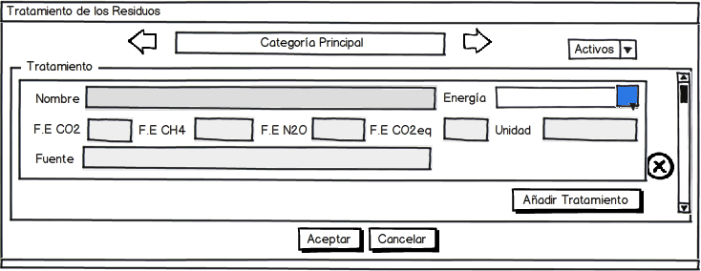

The data to be stored in the database (“tratamientos_residuos” in spanish):

|  |  |  |
| --- | --- | --- |
| Name | Description | Permissions |
| Identificador (Identificator) | Automatically auto increment key, invisible to the user |  |
| Tipo Básico (Basic Type) | Relation to the type it belongs to. Invisible to the user. |  |
| Categoría (Category) | Relation to the category it belongs to. Invisible to the user. |  |
| Nombre (Name) | Waste treatment name | Create/Modify/Delete (only on own records) |
| Emisión CO2 (CO2 Emission) | Decimal data | Create/Modify/Delete (only on own records) |
| Emisión CH4 (CH4 Emission) | Decimal data | Create/Modify/Delete (only on own records) |
| Emisión N2O (NO2 Emission) | Decimal data | Create/Modify/Delete (only on own records) |
| Emisión CO2 equivalente (CO2 Equivalent Emission) | Decimal data | Create/Modify/Delete (only on own records) |
| Unidad (Unit) | Text | Create/Modify/Delete (only on own records) |
| Fuente (Source) | Text | Create/Modify/Delete (only on own records) |
| Energía (Energy) | Relation to the energy used. Invisible to the user. | Create/Modify/Delete (only on own records) |
| Fecha Baja (Down Date) | Will only have value if the record has been disabled |  |
| Usuario Creación Registro  (Creation User) | For the "Track". Invisible. | Only available for an administrator. It can be Listed. |
| Fecha Creación Registro  (Creation Date) | For the "Track". Invisible. | Only available for an administrator. It can be Listed. |
| Usuario Última Modificación (Last Modification User) | For the "Track". Invisible. | Only available for an administrator. It can be Listed. |
| Fecha Última Modificación (Last Modification Date) | For the "Track". Invisible. | Only available for an administrator. It can be Listed. |

##### Raw Materials

As to raw materials, it is important to consider them as inputs to both inventories of any kind of production section, and the processes of transformation.

Must be distinguished according to the type they belong to: Agricultural Production, Livestock Production, Food, Fertilizer and Phytosanitary.

It is necessary that the administrator user discriminates according to categories, the type of raw material that can be considered both as an entry in an inventory as a process of transformation.

For example, to the category of "crops", the user may indicate a fertilizer-type raw material representing the slurry that is used as fertilizer.

Later, in another part of the system during the realization of inventories, to calculate the carbon footprint, the user must indicate the transport associated with the raw material to their exploitation or industry.

If the raw material is own, in the box "carbon footprint" (CO2 eq) the user of the enterprise will indicate the value obtained from the tool. Otherwise, the tool will provide this value as data having the same.

The raw materials screen is presented as follows:

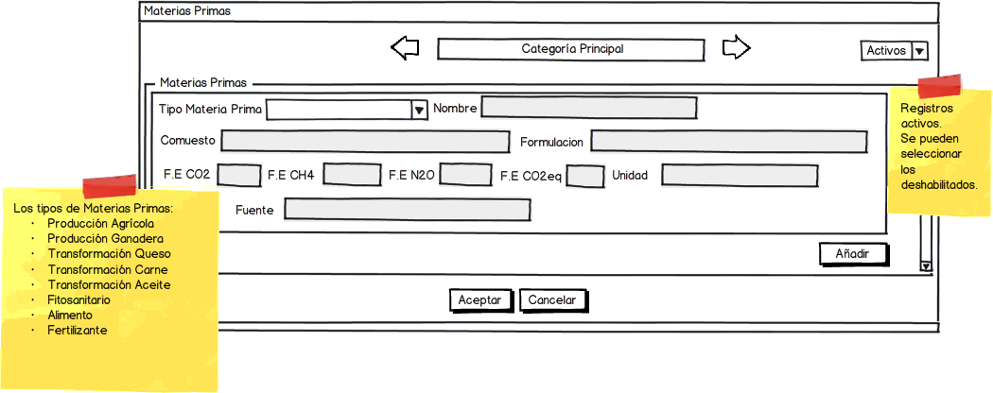

For the case of raw materials (“materias_primas” in spanish):

|  |  |  |
| --- | --- | --- |
| Name | Description | Permissions |
| Identificador (Identificator) | Automatically auto increment key, invisible to the user |  |
| Tipo Básico (Basic Type) | Relation to the type it belongs to. Invisible to the user. |  |
| Categoría (Category) | Relation to the category it belongs to. Invisible to the user. |  |
| Tipo Materia Prima (Raw Material Type) | Allowed types:  -Producción Agrícola  -Producción Ganadera  -Transformación Queso  -Transformación Carne  -Transformación Aceite  -Fitosanitario  -Alimento  -Fertilizante | Create/Modify/Delete (only on own records) |
| Nombre (Name) | Raw material name | Create/Modify/Delete (only on own records) |
| Unidad (Unit) | Text. Be copied to the raw materials of the enterprise. | Create/Modify/Delete (only on own records) |
| Compuesto (composed) | Text | Create/Modify/Delete (only on own records) |
| Formulación (formulation) | Text | Create/Modify/Delete (only on own records) |
| Emisión CO2 (CO2 Emission) | Decimal data | Create/Modify/Delete (only on own records) |
| Emisión CH4 (CH4 Emission) | Decimal data | Create/Modify/Delete (only on own records) |
| Emisión N2O (NO2 Emission) | Decimal data | Create/Modify/Delete (only on own records) |
| Emisión CO2 equivalente (CO2 Equivalent Emission) | Decimal data | Create/Modify/Delete (only on own records) |
| Unidad (Unit) | Text | Create/Modify/Delete (only on own records) |
| Fuente (Source) | Text | Create/Modify/Delete (only on own records) |
| Fecha Baja (Down Date) | Will only have value if the record has been disabled |  |
| Usuario Creación Registro  (Creation User) | For the "Track". Invisible. | Only available for an administrator. It can be Listed. |
| Fecha Creación Registro  (Creation Date) | For the "Track". Invisible. | Only available for an administrator. It can be Listed. |
| Usuario Última Modificación (Last Modification User) | For the "Track". Invisible. | Only available for an administrator. It can be Listed. |
| Fecha Última Modificación (Last Modification Date) | For the "Track". Invisible. | Only available for an administrator. It can be Listed. |

##### Auxiliary Services

Regarding to the auxiliary services, must provide a name and associate the emission factors.

The screen of auxiliary services:

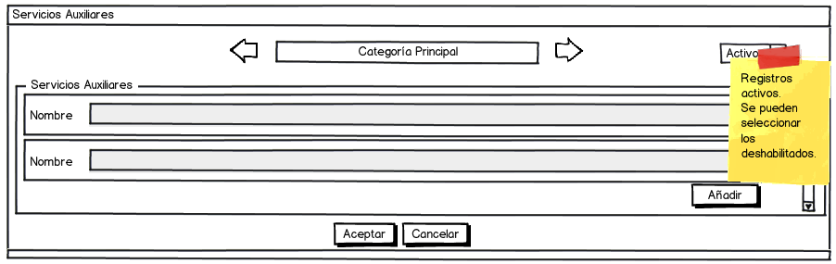

As to database of auxiliary services (“servicios_auxiliares” in spanish):

|  |  |  |
| --- | --- | --- |
| Name | Description | Permissions |
| Identificador (Identificator) | Automatically auto increment key, invisible to the user |  |
| Tipo Básico (Basic Type) | Relation to the type it belongs to. Invisible to the user. |  |
| Categoría (Category) | Relation to the category it belongs to. Invisible to the user. |  |
| Nombre (Name) | Auxiliary service name. | Create/Modify/Delete (only on own records) |
| Fecha Baja (Down Date) | Will only have value if the record has been disabled |  |
| Usuario Creación Registro  (Creation User) | For the "Track". Invisible. | Only available for an administrator. It can be Listed. |
| Fecha Creación Registro  (Creation Date) | For the "Track". Invisible. | Only available for an administrator. It can be Listed. |
| Usuario Última Modificación (Last Modification User) | For the "Track". Invisible. | Only available for an administrator. It can be Listed. |
| Fecha Última Modificación (Last Modification Date) | For the "Track". Invisible. | Only available for an administrator. It can be Listed. |

##### Consumables

Consumables are similar to the auxiliary services unless they need a unit of measurement that characterizes it.

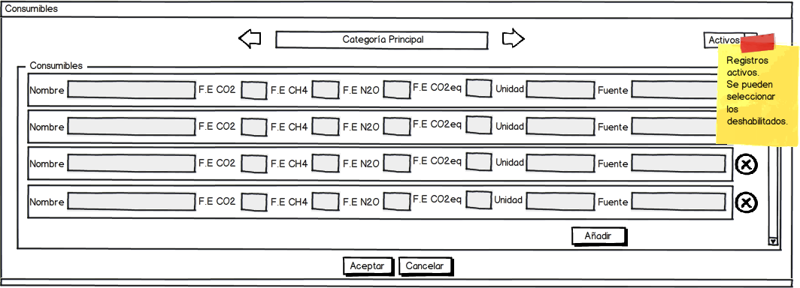

The data contained in the database (“consumibles” in spanish):

|  |  |  |
| --- | --- | --- |
| Name | Description | Permissions |
| Identificador (Identificator) | Automatically auto increment key, invisible to the user |  |
| Tipo Básico (Basic Type) | Relation to the type it belongs to. Invisible to the user. |  |
| Categoría (Category) | Relation to the category it belongs to. Invisible to the user. |  |
| Nombre (Name) | Consumable name | Create/Modify/Delete (only on own records) |
| Unidad (Unit) | Text | Create/Modify/Delete (only on own records) |
| Emisión CO2 (CO2 Emission) | Decimal data | Create/Modify/Delete (only on own records) |
| Emisión CH4 (CH4 Emission) | Decimal data | Create/Modify/Delete (only on own records) |
| Emisión N2O (NO2 Emission) | Decimal data | Create/Modify/Delete (only on own records) |
| Emisión CO2 equivalente (CO2 Equivalent Emission) | Decimal data | Create/Modify/Delete (only on own records) |
| Fuente (Source) | Text | Create/Modify/Delete (only on own records) |
| Fecha Baja (Down Date) | Will only have value if the record has been disabled |  |
| Usuario Creación Registro  (Creation User) | For the "Track". Invisible. | Only available for an administrator. It can be Listed. |
| Fecha Creación Registro  (Creation Date) | For the "Track". Invisible. | Only available for an administrator. It can be Listed. |
| Usuario Última Modificación (Last Modification User) | For the "Track". Invisible. | Only available for an administrator. It can be Listed. |
| Fecha Última Modificación (Last Modification Date) | For the "Track". Invisible. | Only available for an administrator. It can be Listed. |

##### Products

Case of products is similar to raw materials unless these are to be understood such outputs of inventories of both crops and animals and the processes of transformation.

These products may or may not coincide with the final products or end uses of the exploitation or industry. This distinction only depends whether the user wants inventory its collection, or calculate the carbon footprint of it.

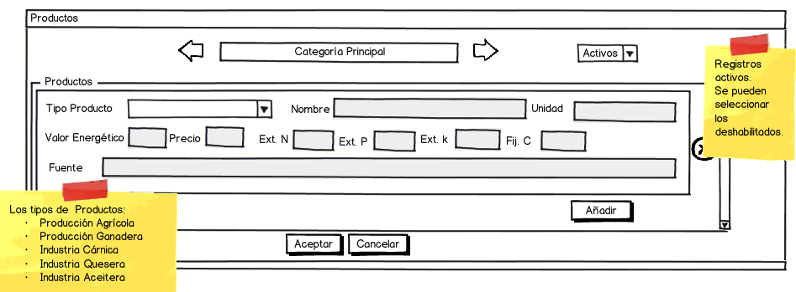

The data from database for the products (“productos” in spanish):

|  |  |  |
| --- | --- | --- |
| Name | Description | Permissions |
| Identificador (Identificator) | Automatically auto increment key, invisible to the user |  |
| Tipo Básico (Basic Type) | Relation to the type it belongs to. Invisible to the user. |  |
| Categoría (Category) | Relation to the category it belongs to. Invisible to the user. |  |
| Tipo Producto (Producto type) | Allowed types:  -Producción Agrícola  -Producción Ganadera  -Transformación Queso  -Transformación Carne  -Transformación Aceite | Create/Modify/Delete (only on own records) |
| Nombre (Name) | Product name | Create/Modify/Delete (only on own records) |
| Unidad (unit) | Text | Create/Modify/Delete (only on own records) |
| Precio (Prize) | Decimal Data | Create/Modify/Delete (only on own records) |
| Fuente (Source) | Data Source | Create/Modify/Delete (only on own records) |
| Fijación C (C Fixation) | Decimal Data | Create/Modify/Delete (only on own records) |
| Extracción N (N Extraction) | Decimal Data | Create/Modify/Delete (only on own records) |
| Extracción P (P Extraction) | Decimal Data | Create/Modify/Delete (only on own records) |
| Extracción K (K Extraction) | Decimal Data | Create/Modify/Delete (only on own records) |
| Valor energético (Energetic value) | Decimal Data | Create/Modify/Delete (only on own records) |
| Fecha Baja (Down Date) | Will only have value if the record has been disabled |  |
| Usuario Creación Registro  (Creation User) | For the "Track". Invisible. | Only available for an administrator. It can be Listed. |
| Fecha Creación Registro  (Creation Date) | For the "Track". Invisible. | Only available for an administrator. It can be Listed. |
| Usuario Última Modificación (Last Modification User) | For the "Track". Invisible. | Only available for an administrator. It can be Listed. |
| Fecha Última Modificación (Last Modification Date) | For the "Track". Invisible. | Only available for an administrator. It can be Listed. |

#### Transformation Processes and Final Products

In this section the administrator user can work with scopes or sectors in that can be framed final products, such as: cheese, oil, Transformed Meat and also consider create new ones.

For each these scopes can be created final products. It should be understood that the entity of final product symbolizes the system products obtained after the transformation process. In addition, for each of them, they can consider their emission factors on use phase, which will serve the overall calculation tool for the functional unit.

In another part of system, an enterprise user may indicate the functional units with which it works. Do so it should indicate the final product as a result of which gets its functional unit. In this way, the tool may retrieve the processes associated with the transformation of the product and at the same time, have the values ​​of the final stage of use thereof. use the tool will calculate the total functional unit

On the other hand the transformation processes can lead associated with one or more machines that must be listed by an administrator user.

The screens on the characterization of final products and associated processes are:

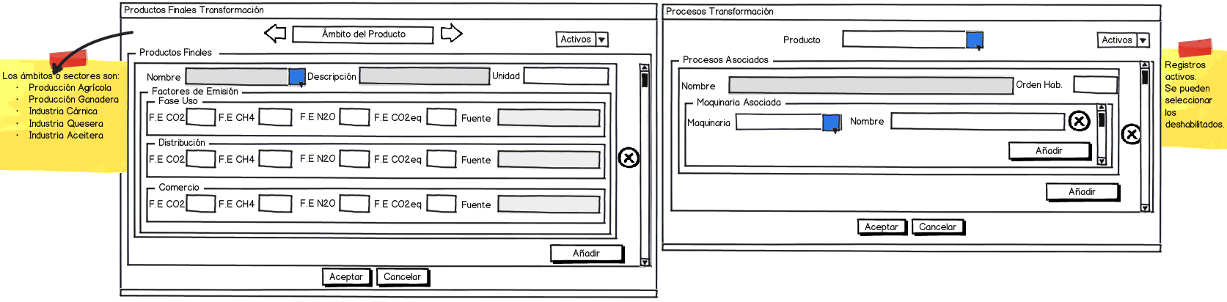



After clicking on the blue square a screen will appear with machinery selection identified as transformation industry ("Ind. Trans.").

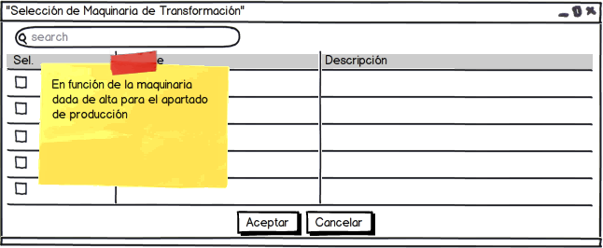

For the case of the final products (“productos_finales” in spanish):

|  |  |  |
| --- | --- | --- |
| Name | Description | Permissions |
| Identificador (Identificator) | Automatically auto increment key, invisible to the user |  |
| Tipo Básico (Basic Type) | Relation to the type it belongs to. Invisible to the user. |  |
| Categoría (Category) | Relation to the category it belongs to. Invisible to the user. |  |
| Nombre (Name) | Final product name | Create/Modify/Delete (only on own records) |
| Descripción (Description) | Text | Create/Modify/Delete (only on own records) |
| Unidad (Unit) | Text | Create/Modify/Delete (only on own records) |
| Emisión CO2 Fase Uso (CO2 Use Phase Emission) | Decimal data | Create/Modify/Delete (only on own records) |
| Emisión CH4 Fase Uso (CH4 Use Phase Emission) | Decimal data | Create/Modify/Delete (only on own records) |
| Emisión N2O Fase Uso (NO2 Use Phase Emission) | Decimal data | Create/Modify/Delete (only on own records) |
| Emisión CO2 equivalente Fase Uso (CO2 Equivalent Use Phase Emission) | Decimal data | Create/Modify/Delete (only on own records) |
| Fuente Uso (Use Phase Source) | Text | Create/Modify/Delete (only on own records) |
| Emisión CO2 Distribución (CO2 Distribution Phase Emission) | Decimal data | Create/Modify/Delete (only on own records) |
| Emisión CH4 Distribución (CH4 Distribution Phase Emission) | Decimal data | Create/Modify/Delete (only on own records) |
| Emisión N2O Distribución (N2O Distribution Phase Emission) | Decimal data | Create/Modify/Delete (only on own records) |
| Emisión CO2 eq Distribución (CO2 Equivalent Distribution Phase Emission) | Decimal data | Create/Modify/Delete (only on own records) |
| Fuente Distribución (Distribution Source) | Text | Create/Modify/Delete (only on own records) |
| Emisión CO2 Comercio (CO2 Trade Phase Emission) | Decimal data | Create/Modify/Delete (only on own records) |
| Emisión CH4 Comercio (CH4 Trade Phase Emission) | Decimal data | Create/Modify/Delete (only on own records) |
| Emisión N2O Comercio (N2O Trade Phase Emission) | Decimal data | Create/Modify/Delete (only on own records) |
| Emisión CO2 eq Comercio (CO2 Equivalent Trade Phase Emission) | Decimal data | Create/Modify/Delete (only on own records) |
| Fuente Comercio (Trade Source) | Text | Create/Modify/Delete (only on own records) |
| Fecha Baja (Down Date) | Will only have value if the record has been disabled |  |
| Usuario Creación Registro  (Creation User) | For the "Track". Invisible. | Only available for an administrator. It can be Listed. |
| Fecha Creación Registro  (Creation Date) | For the "Track". Invisible. | Only available for an administrator. It can be Listed. |
| Usuario Última Modificación (Last Modification User) | For the "Track". Invisible. | Only available for an administrator. It can be Listed. |
| Fecha Última Modificación (Last Modification Date) | For the "Track". Invisible. | Only available for an administrator. It can be Listed. |

As for the data of transformation processes (“procesos_transformacion” in spanish):

|  |  |  |
| --- | --- | --- |
| Name | Description | Permissions |
| Identificador (Identificator) | Automatically auto increment key, invisible to the user |  |
| Producto Final (Final Product) | Relation to the final product. Invisible to the user. | Create/Modify/Delete (only on own records) |
| Nombre (Name) | Transformation processe name | Create/Modify/Delete (only on own records) |
| Orden Habitual (Regular order) | Numeric Data | Create/Modify/Delete (only on own records) |
| Fecha Baja (Down Date) | Will only have value if the record has been disabled |  |
| Usuario Creación Registro  (Creation User) | For the "Track". Invisible. | Only available for an administrator. It can be Listed. |
| Fecha Creación Registro  (Creation Date) | For the "Track". Invisible. | Only available for an administrator. It can be Listed. |
| Usuario Última Modificación (Last Modification User) | For the "Track". Invisible. | Only available for an administrator. It can be Listed. |
| Fecha Última Modificación (Last Modification Date) | For the "Track". Invisible. | Only available for an administrator. It can be Listed. |
| Details (“proceso_maquinarias” in spanish) | | |
| Maquinaria (Machinery) | It is a relation table, ie many machines can be associated to the transformation process, as needed. |  |

On the screen of transformation processes the user indicated can create as many processes as it deems involved in the processing of the selected product.

In addition may associate each process to a machine of the type of transformation machine.

It allows the option of adding a regular order, if necessary to recover a complete itinerary of the process.

In point of transformation, the user can tell each of these processes, both raw materials input, such the energy consumed or waste products obtained after treatment.

#### Provinces and Cities

The user can create records for the average temperature of each city and average excreted by each animal in question, for each province with which to work the system and subsequently influence the calculation of carbon footprint.

In both cases, being such a large number of records, it would be necessary to create a routine transfer of data from the Excel provided to the corresponding table of database.

Similarly, then shows the maintenance screen of the cities of the provinces with their corresponding temperatures.

The maintenance screen associated with the excreted by type of animal, by province, will be very similar.

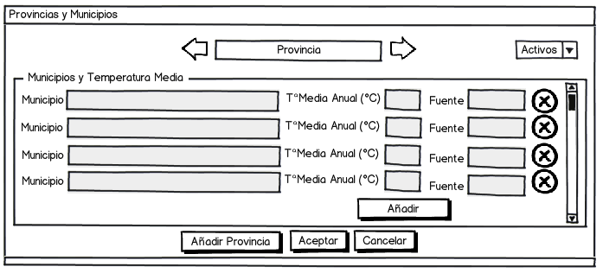

For excreta:

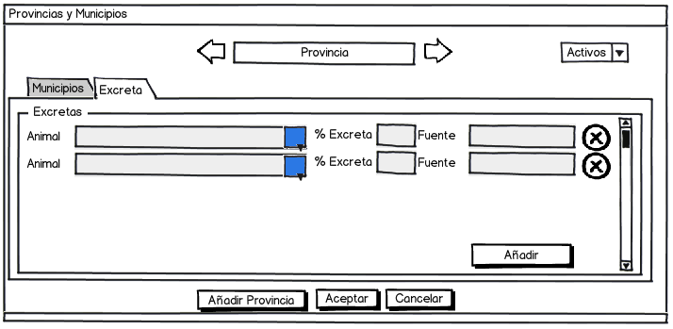

The provinces table (“provincias” in spanish):

|  |  |  |
| --- | --- | --- |
| Name | Description | Permissions |
| Identificador (Identificator) | Automatically auto increment key, invisible to the user |  |
| Nombre (Name) | Province name | Create/Modify/Delete (only on own records) |
| Fecha Baja (Down Date) | Will only have value if the record has been disabled |  |
| Usuario Creación Registro  (Creation User) | For the "Track". Invisible. | Only available for an administrator. It can be Listed. |
| Fecha Creación Registro  (Creation Date) | For the "Track". Invisible. | Only available for an administrator. It can be Listed. |
| Usuario Última Modificación (Last Modification User) | For the "Track". Invisible. | Only available for an administrator. It can be Listed. |
| Fecha Última Modificación (Last Modification Date) | For the "Track". Invisible. | Only available for an administrator. It can be Listed. |

And the cities table (“municipios” in spanish):

|  |  |  |
| --- | --- | --- |
| Name | Description | Permissions |
| Identificador (Identificator) | Automatically auto increment key, invisible to the user |  |
| Provincia (Province) | Relation to the province. Invisible to the user. | Create/Modify/Delete (only on own records) |
| Municipio (township) | Township name | Create/Modify/Delete (only on own records) |
| Temperatura (Temperature) | Decimal data | Create/Modify/Delete (only on own records) |
| Fuente (Source) | Data source | Create/Modify/Delete (only on own records) |
| Fecha Baja (Down Date) | Will only have value if the record has been disabled |  |
| Usuario Creación Registro  (Creation User) | For the "Track". Invisible. | Only available for an administrator. It can be Listed. |
| Fecha Creación Registro  (Creation Date) | For the "Track". Invisible. | Only available for an administrator. It can be Listed. |
| Usuario Última Modificación (Last Modification User) | For the "Track". Invisible. | Only available for an administrator. It can be Listed. |
| Fecha Última Modificación (Last Modification Date) | For the "Track". Invisible. | Only available for an administrator. It can be Listed. |

### Security

This menu includes all activities corresponding to the creation, modification, etc. of sensitive data in the management of the tool by each permitted user.

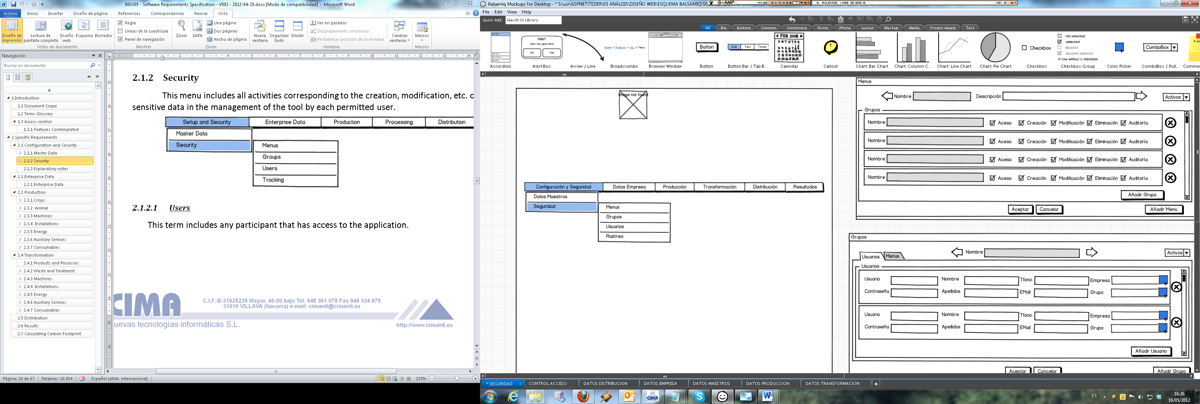

#### Users

This term includes any participant that has access to the application.

Each user of the application will be associated with a group or role. In the case of users of a holding, the existence of them only makes sense when associated with an enterprise. Therefore, a non-administrator, need to belong to an enterprise.

The administrator user is who must create both the enterprise and the users associated with the same or other admin users.

Users screen can be like this:

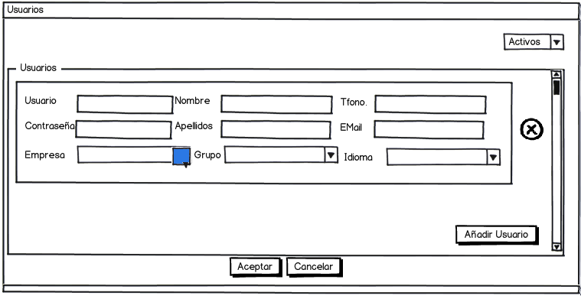

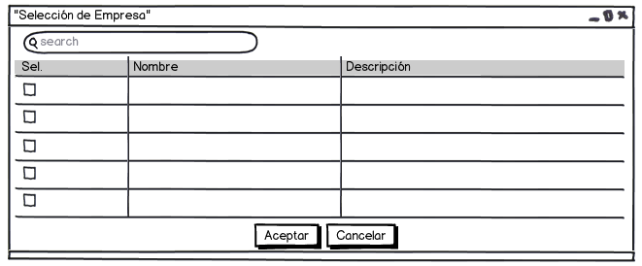As the key is encrypted, this is not displayed in the text box. If it’s introduced a new password it replaces the previous one after being encrypted. For safety, the new password must contain at least one uppercase letter, and be of a length equal to or greater than 8 characters. If doesn't meet the requirements will show warning message and no changes will be saved.

And the database (“usuarios” in spanish):

|  |  |  |
| --- | --- | --- |
| Name | Description | Permissions |
| Usuario (User) | Username, Key of the table |  |
| Contraseña (Password) | Text, encripted in MD5 | Create/Modify/Delete (only on own records) |
| Grupo (Group) | Relation to the group. Invisible to the user. |  |
| Empresa (Enterprise) | Relation to the enterprise. Invisible to the user. |  |
| Nombre (name) | Text | Create/Modify/Delete (only on own records) |
| Apellidos (surname) | Text | Create/Modify/Delete (only on own records) |
| Email | Text | Create/Modify/Delete (only on own records) |
| Teléfono (Telephone) | Text | Create/Modify/Delete (only on own records) |
| Idioma (Language) | Text | Create/Modify/Delete (only on own records) |
| Fecha Baja (Down Date) | Will only have value if the record has been disabled |  |
| Usuario Creación Registro  (Creation User) | For the "Track". Invisible. | Only available for an administrator. It can be Listed. |
| Fecha Creación Registro  (Creation Date) | For the "Track". Invisible. | Only available for an administrator. It can be Listed. |
| Usuario Última Modificación (Last Modification User) | For the "Track". Invisible. | Only available for an administrator. It can be Listed. |
| Fecha Última Modificación (Last Modification Date) | For the "Track". Invisible. | Only available for an administrator. It can be Listed. |

For security, the password is stored using the MD5 algorithm. It can’t be recovered, in case of forgotten will have to generate a new one.

To allow multi-language interface, when the user access to one screen it will look in a specific directory for XML file that matches with the user’s language. For example, if the user’s language is Italian, the file is searched and loaded Italian.xml the interface with the texts contained in that document. If the user assigned XML language file isn’t in the directory or it’s not a valid language file the interface will be displayed by default in English language.

The order of the data within the XML file is a free choice. This should contain as many different fields as necessary for the complete translation of the interface. From the XML file structure can be determined if this is valid file or not

The combo box in the user’s language will be added as many options as XML files exist in the directory when accessing the screen.

An example of English.XML file it can be like this:

<eureners> //Application name

<Users.php> //Screen name

<name>Name</name> //Text assigned to “name” field in English

<password>Password<password> //Text assigned to “password” field in English

</Users.php> //end of screen name

</ eureners > //end of application name

Same structure to Spanish language (Spanish.XML):

<eureners> //Application name

<Users.php> //Screen name

<name>Nombre</name> //Text assigned to “name” field in Spanish

<password>Contraseña</password> //Text assigned to “password” field in Spanish

</Users.php> //end of screen name

</ eureners > //end of application name

#### Groups

It have been established the following groups, with corresponding modules and permissions.

|  |  |  |
| --- | --- | --- |
| Groups | Menu | permissions |
| Administrator (AD) | Setup and Security, Enterprise Data, Exploitation, Transformation, Distribution and Consumer Use | Create/Modify/Delete (only on own records) |
| User (US) | Depends on if it is a Exploitation or Industry. | Create/Modify/Delete (only on own records) |

Perhaps in future be necessary to change the permissions of the groups or create new ones with different permissions, so it needed a screen like the one shown below:

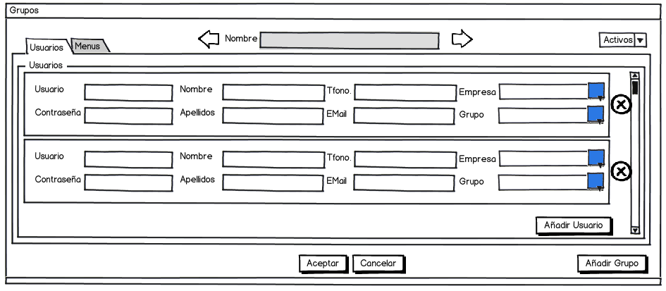

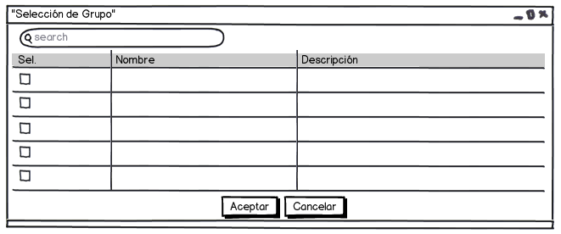As shown, for convenience users can be added to the selected group and modify its permissions within the same screen.

The group table is as follows (“grupos” in spanish):

|  |  |  |
| --- | --- | --- |
| Name | Description | Permissions |
| Identificador (Identificator) | Automatically auto increment key, invisible to the user |  |
| Nombre (Name) | Group name | Create/Modify/Delete (only on own records) |
| Fecha Baja (Down Date) | Will only have value if the record has been disabled |  |
| Usuario Creación Registro  (Creation User) | For the "Track". Invisible. | Only available for an administrator. It can be Listed. |
| Fecha Creación Registro  (Creation Date) | For the "Track". Invisible. | Only available for an administrator. It can be Listed. |
| Usuario Última Modificación (Last Modification User) | For the "Track". Invisible. | Only available for an administrator. It can be Listed. |
| Fecha Última Modificación (Last Modification Date) | For the "Track". Invisible. | Only available for an administrator. It can be Listed. |

#### Permissions

This section refers to actions that are allowed to groups or roles of the system, along with menus and menu options which can work.

Permissions from menu screen:

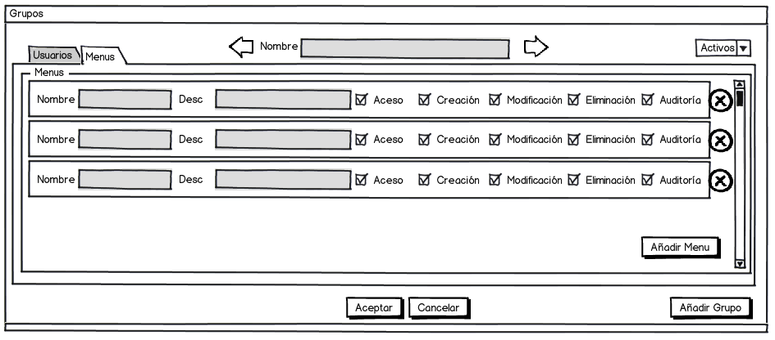

Permissions from groups screen:



For convenience at the menu screen can be modified the permissions of the current menu for all groups.

(“permisos” in spanish)

|  |  |  |
| --- | --- | --- |
| Name | Description | Permissions |
| Menú (Menu) | Relation to the menu. Invisible to the user. |  |
| Grupo (Group) | Relation to the group. Invisible to the user. |  |
| Permisos (Permissions) | Decimal Data. Each bit enables (1) or disables (0) an action. From least significant bit (LSB) to most significant bit (MSB):   * Access * Creation * Modification * Elimination * Auditing | Create/Modify/Delete (only on own records) |
| Fecha Baja (Down Date) | Will only have value if the record has been disabled |  |
| Usuario Creación Registro  (Creation User) | For the "Track". Invisible. | Only available for an administrator. It can be Listed. |
| Fecha Creación Registro  (Creation Date) | For the "Track". Invisible. | Only available for an administrator. It can be Listed. |
| Usuario Última Modificación (Last Modification User) | For the "Track". Invisible. | Only available for an administrator. It can be Listed. |
| Fecha Última Modificación (Last Modification Date) | For the "Track". Invisible. | Only available for an administrator. It can be Listed. |

Permissions example:

Permissions = 29; in binary 11101 =>> allow Access, modification, elimination and auditing. Creation not allowed.

#### Menus

When loading the screen only those menu options that current user has permission to access must be shown (see permissions), according to the group that belongs. A menu or submenu is displayed if the user has permission to access at least one of his options, otherwise remain hidden. For this, each screen of the application must have an associated name, which will be the one going to look for the table menus. Along with the current user group will be sought at the permissions table.

The next image shows the permissions of each group with the selected menu (shows all existing groups, whether or not related to the selected menu):

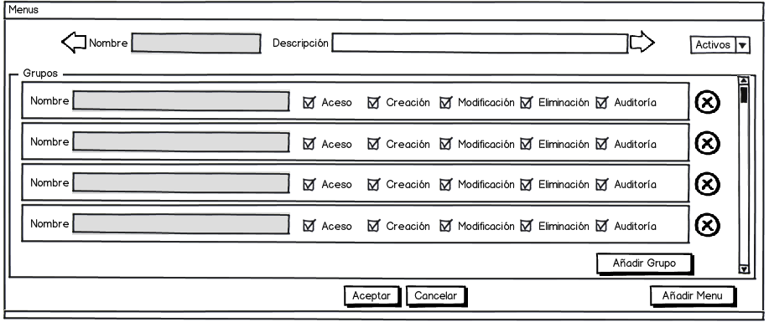

Menu database (“menus” in spanish):

|  |  |  |
| --- | --- | --- |
| Name | Description | Permissions |
| Identificador (Identificator) | Automatically auto increment key, invisible to the user |  |
| Nombre (Name) | Menu name |  |
| Descripción (Description) | Text. Shown at the top of each screen. | Create/Modify/Delete (only on own records) |
| Fecha Baja (Down Date) | Will only have value if the record has been disabled |  |
| Usuario Creación Registro  (Creation User) | For the "Track". Invisible. | Only available for an administrator. It can be Listed. |
| Fecha Creación Registro  (Creation Date) | For the "Track". Invisible. | Only available for an administrator. It can be Listed. |
| Usuario Última Modificación (Last Modification User) | For the "Track". Invisible. | Only available for an administrator. It can be Listed. |
| Fecha Última Modificación (Last Modification Date) | For the "Track". Invisible. | Only available for an administrator. It can be Listed. |

Access: Allows the user to access the screen associated with the menu. If the user does not have this permission will not be shown the menu option.

Creation: Allows the user to create new records on the screen. If not have permission message is displayed when attempting to create a new record.

Modification: Allows the user to edit records. If not have permission to change it will show error message when trying to modify a record. Enable or disable a record is a means of modification, so that permission will be evaluated when a user wants to enable or disable a record. When a user modifies a record, the fields "last modification user" and "last modification date" will change with the current user and date.

Elimination: Allows the user to delete the selected record. If not have this permission will show error message when trying to delete a record. Currently, records can’t be deleted, but this permission may be necessary in the future.

Audit: Allows the user to access audit information. If no such permission will not display the audit icon on the screen

#### Audit

The audit allows know (the information displayed is always read-only) who created a record in the database and last user who made modifications along with the date of each event. In all screens (menus) on which the user has permission to audit, it should display an icon (not included on the screens pictures of the document) in both the record and its associated lines, which allow the user to access the audit log data. To do this, pressing the icon shown in the figure will show a screen like the following:

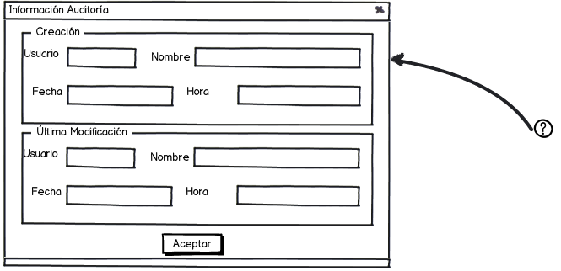

The data shown come from the fields “Creation user”, “Creation date”, Last modification user” and “last modification date” of the selected record.

Example of access to menus screen with audit permissions. The down left audit icon shows the audit of the selected menu. The audit icon on the left of each group shows the audit of the correspondent group.



#### Tracking

For every action that a user can made on a record (access, creation, modification or deletion. The audit query action is not recorded in the log) is stored in the "Log" table of the database a record with the data shown in the log table definition (menu, user, current date and time, action and key/s of the register). The tracking screen allows query the actions taken by various filters (see screen image).

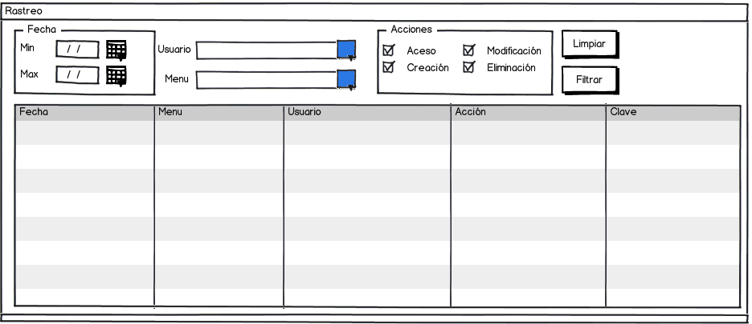

User selection screen:

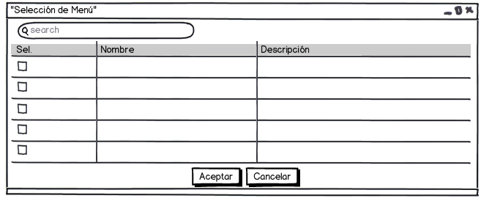

Menu selection screen:

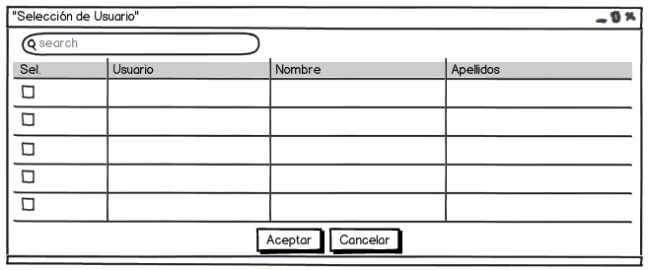

Log table format (“log” in spanish):

|  |  |  |
| --- | --- | --- |
| Name | Description | Permissions |
| Identificador (Identificator) | Automatically auto increment key, invisible to the user |  |
| Menú (Menu) | Code menu (screen) on which the operation is performed |  |
| Usuario (User) | User code |  |
| Fecha (Date) | Action datetime |  |
| Acción (Action) | Performed action:   1. Access 2. Creation 3. Modification 4. Delete |  |
| Clave (Key) | Register key/s affected by the action |  |

### Explanatory notes

In many occasions, are commented the options "Enable/Disable". It is necessary to clarify from the outset that both options will not appear at the same time, due to be enabled depending on the corresponding case.

Whenever wish to change the status of a record, activating it, disabling it or removing it, the system displays a message indicating the type of process that the user wants to perform and requested a validation of it to continue with it.

If a record is marked as inactive or "disabled" can’t make changes to his data. This will need to re activate the corresponding entity. Disabled record can’t appear in the corresponding selection screens (operates as a filter).

Sample of selection screen:

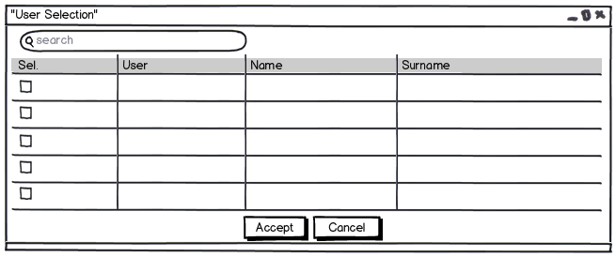

In this case only enabled users appear on the user selection screen.

As regards the possibility of display considered inactive records for the system, will enable a filtering option for this purpose. By default, the application will always load the data considered active.

In all records with emission factors (CO2, CH4, N2O and CO2 eq) CO2 eq if is filled will be deleted the other factors.

When there are sufficient data of CH4, N2O and CO2 it may use. In otherwise only use the value of CO2 eq.

The final emissions (CO2 eq) will come from:

Multiply the value of CH4 emissions and N2O by their CO2 equivalent. Add the two values ​​to the CO2 value and multiply by the number (distance, cycles / square, etc.) as needed. If there is only CO2eq value multiplied by the corresponding amount.

CO2 equivalent value of CH4 and N2O (or other gas) is obtained from the table "Gases" which formula matches the gas in question and multiplying by the GWP value.

The actions are shown below, include all the functionality provided, therefore, not be explained according to the user role, but with a general overview.

In all screens with references to external records tables will show the name of the referenced record.

For example:

A user belongs to a group, so instead of showing the group identificator, the display will show the users group name.

## Enterprise Data

In this section be able to create enterprises with their users.

For the creation of an enterprise it is necessary that the administrator user Insert name company's business, the scope of the business and user data (mandatory). Subsequently, if known and desired, the remaining data needed for proper registration and characterization of the same.

Needless to say the other data not considered mandatory, the company enabled user can input, so subsequent.

The menu for this option is as follows:

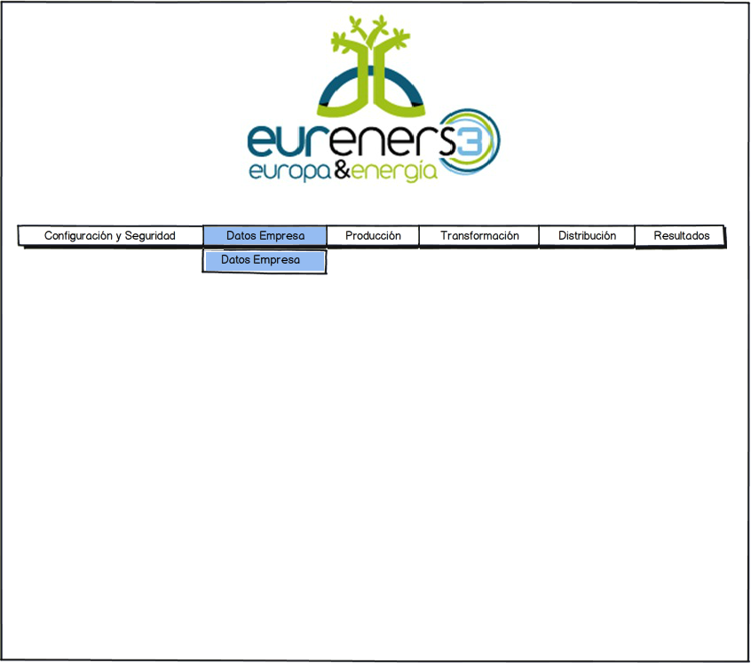

### Enterprise Data

As already mentioned, in this option, the administrator user can create new enterprises or display existing ones.

It should characterize the type of enterprise, being possible to point at the same time, one of three options: Agriculture, Livestock or Transformation. At least one option must be checked, but the enterprise user may not access their corresponding menu options.

On the other hand, it is necessary to note the municipality where the company is located because if it is of type livestock, the municipality itself determines a set of values ​​required to subsequent obtain carbon footprint.

In the section of final products, the administrator user or the company user shall indicate the type of product which will proceed to calculate the carbon footprint. Depending on product type is selected, the tool will display the associated categories with the selected type or taking into account the categories of final products (in the case of the transformation) or categories of agricultural products or livestock.

The property enterprise screen is presented below:

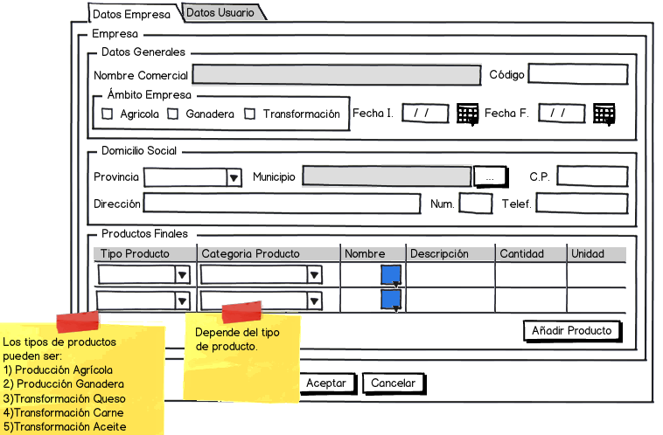

The next screen is used to make the selection according to the criteria previously selected:

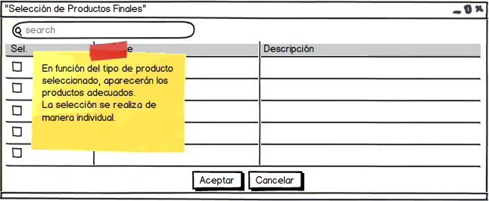

The User Data tab allows the possibility of adding more of a user with permission to the own company.

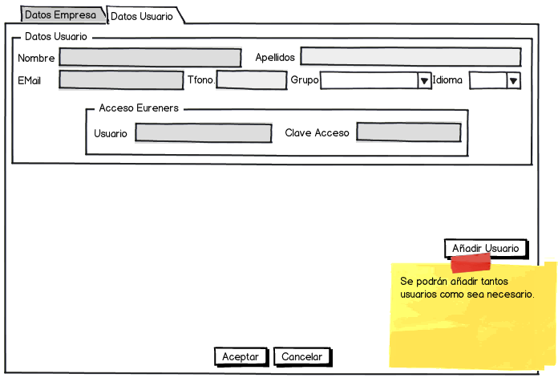

The data required for registering a new enterprise are (“empresas” in spanish):

|  |  |  |
| --- | --- | --- |
| Data | Description | Groups |
| Nombre Comercial (Name) | Enterprise name | Administrador |
| Código (Code) | Text |
| Fecha Inicio (Init date) | Study initiation date |
| Fecha Fin (End date) | Study end date |
| Es Agrícola (is Agricultural) | 1 True, 0 False. |
| Es Ganadera (is Livestock) | 1 True, 0 False. |
| Es Transformación (is Transformation) | 1 True, 0 False. |
| Provincia (Province) | Relation to the province. Invisible to the user. | Administrador/Usuario |
| Municipio (Township) | Relation to the township. Invisible to the user. |
| Código Postal (Postal code) | Text |
| Dirección (Address) | Text |
| Número (Number) | Text |
| Teléfono (Telephone) | Text |
| Final products detail (“empresa_productos_resultantes” in spanish) | | |
| Tipo Producto (Product type) | Allowed values:   * Agrícola * Ganadero * De Transformación | Administrador/Usuario |
| Categoría del Producto (Product category) | Relation to the category. Invisible to the user. |
| Nombre (Name) | Copied from the selected product |
| Descripción (Description) | Copied from the selected product |
| Cantidad (Amount) | Numeric data |  |
| Unidad (Unit) | Copied from the selected product. Can’t be changed. |  |
| Users details (“usuarios” in spanish) | | |
| Nombre (Name) | Dato que posteriormente podrá ser modificado por el usuario | Administrador y posteriormente Usuario |
| Apellidos (Surname) | Dato que posteriormente podrá ser modificado por el usuario |
| Teléfono (Telephone) | Text |
| Email | Text |
| Idioma (Language) | Text. For multi-language interface. |
| Nombre de Acceso (user) | Text |
| Clave de Acceso (password) | Text |

An Enterprise can be Agricultural (agricultural scope), Livestock (livestock scope), Transformation (transformation scope) or combination of several (i.e: agricultural and transformation scope).

## Producción

In the production section, the user of the enterprise concerned owning a share of exploitation, can set the inventory of his exploitation, raw materials involved work, and waste products obtained, along with the treatment of same.

All records created from the "Producción" (production) menu have the "Es Producción" (is production) field = 1 and the "Es Transformación" (is transformation) field = 0 (As opposed to records created from the processing menu).

The menu options depend on the configuration of the company.

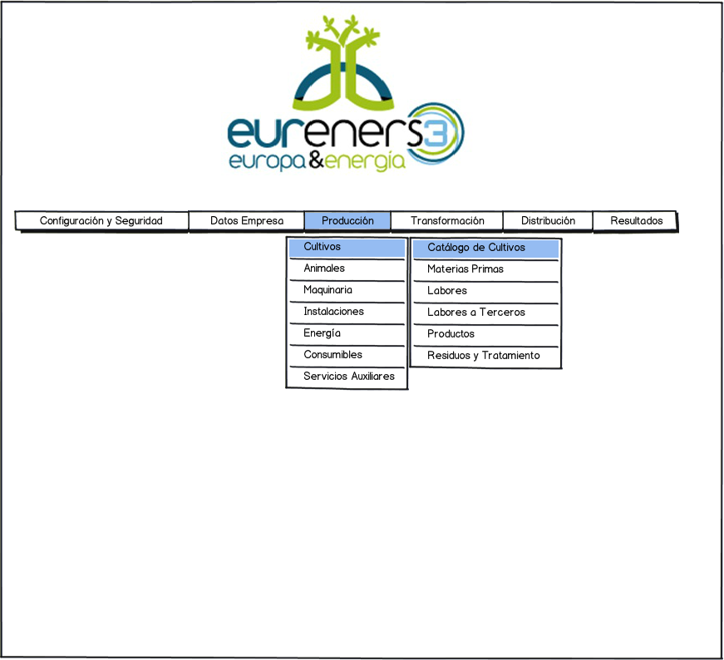

### Crops

#### Crop Catalog

Regarding the inventory of crops, it is necessary that the user indicates a series of data such as the category, the crop, surface, performance, and the percentage obtained.

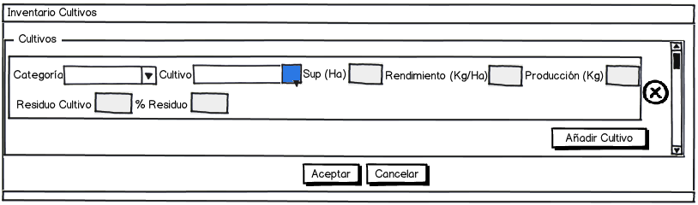

The "Producción" field is calculated by multiplying the area by performance. Not stored anywhere.

Depending on the selected category, the screen that contains all crops discharged onto the system as it:

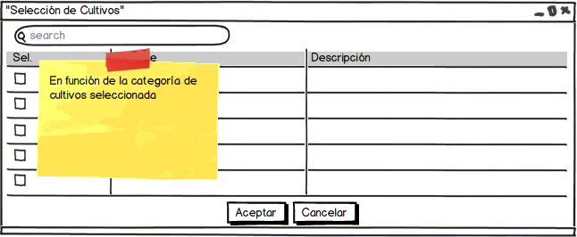

Fields store data that associated the types of crops with production enterprise and at the same time, characterized.

(“empresa_cultivos” in spanish)

|  |  |  |
| --- | --- | --- |
| Name | Description | Permissions |
| Identificador (Identificator) | Automatically auto increment key, invisible to the user |  |
| Empresa (Enterprise) | Tanto si es de producción como si es de transformación |  |
| Es Producción (Is Production) | Equals 1 because the record is created by production menu. |  |
| Es Transformación (Is Transformation) | Equals 0 because the record isn’t created by transformation menu. |  |
| Tipo Básico (Basic Type) | Relation to the type it belongs to. Invisible to the user. |  |
| Categoría (Category) | Relation to the category it belongs to. Invisible to the user. |  |
| Cultivo (crop) | Relation to the selected crop. Invisible to the user. |  |
| Superficie (Surface) | Decimal Data | Create/Modify/Delete (only on own records) |
| Rendimiento (Performance) | Decimal Data | Create/Modify/Delete (only on own records) |
| Residuo Cultivo (Crop Waste) | Decimal Data | Create/Modify/Delete (only on own records) |
| Porcentaje Residuo (Waste percentage) | Decimal Data | Create/Modify/Delete (only on own records) |
| Fecha Baja (Down Date) | Will only have value if the record has been disabled |  |
| Usuario Creación Registro  (Creation User) | For the "Track". Invisible. | Only available for an administrator. It can be Listed. |
| Fecha Creación Registro  (Creation Date) | For the "Track". Invisible. | Only available for an administrator. It can be Listed. |
| Usuario Última Modificación (Last Modification User) | For the "Track". Invisible. | Only available for an administrator. It can be Listed. |
| Fecha Última Modificación (Last Modification Date) | For the "Track". Invisible. | Only available for an administrator. It can be Listed. |

#### Raw Materials

In this section, the user of the producing company should assign the input raw materials inventories, both crops and livestock. So internally, the system maintains a unique relationship between the company, the type of enterprise (livestock or production) the basic type along with his selected category and finally, the raw material.

On the other hand on the screen must enter required data for calculating corresponding.

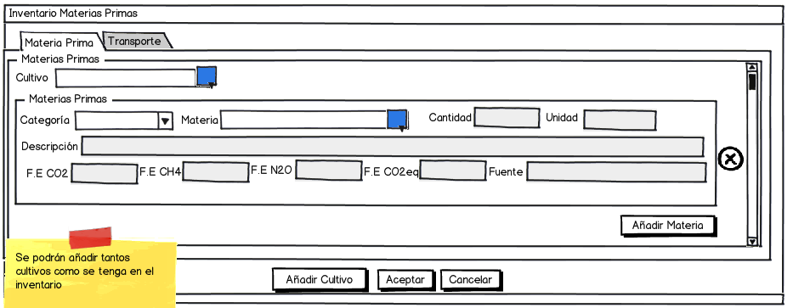

Fields "Unidad" (Unit), "Fuente" (Source) and emission factors (CO2, CH4, N2O and CO2eq) are copied from the master according to the selected raw materials. All them can be modified except the Unit.

And the corresponding transports:

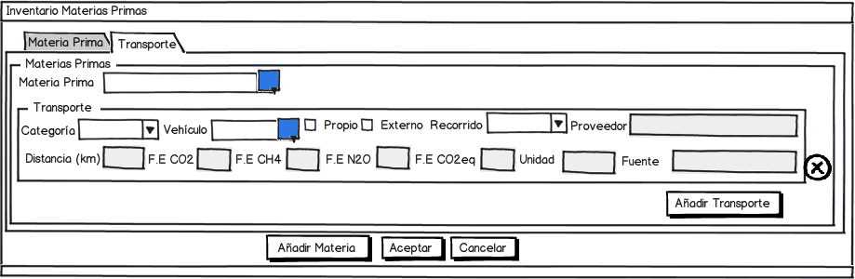

If "Propio" (own) option selected it’s considered for calculations of scope 1, if "Externo" (external) selected then shall be taken into consideration for calculation of scope 2.

The crops selection is done through a screen that displays the crops previously recorded in the inventory.

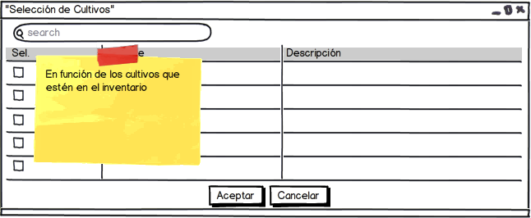

For the selection of raw materials and vehicles, something similar happen. In the case of raw materials can be selected those which are discharged from the system. For vehicles, be recovered are those which transport rate for the same raw materials. It must be registered in the system previously.

On database, the following data are collected (“empresa_materias_primas” in spanish).

|  |  |  |
| --- | --- | --- |
| Name | Description | Permissions |
| Identificador (Identificator) | Automatically auto increment key, invisible to the user |  |
| Empresa (Enterprise) | Relation to the associated enterprise. Invisible to the user. |  |
| Es Producción (Is Production) | Equals 1 because the record is created by production menu. |  |
| Es Transformación (Is Transformation) | Equals 0 because the record isn’t created by transformation menu. |  |
| Tipo Básico (Basic Type) | Relation to the type it belongs to. Invisible to the user. |  |
| Categoría (Category) | Relation to the category it belongs to. Invisible to the user. |  |
| Cultivo (crop) | Relation to the associated crop. Invisible to the user. |  |
| Materia Prima (Raw Material) | Relation to the associated raw material. Invisible to the user. |  |
| Descripción (Description) | Text | Create/Modify/Delete (only on own records) |
| Emisión CO2 (CO2 Emission) | Decimal data | Create/Modify/Delete (only on own records) |
| Emisión CH4 (CH4 Emission) | Decimal data | Create/Modify/Delete (only on own records) |
| Emisión N2O (NO2 Emission) | Decimal data | Create/Modify/Delete (only on own records) |
| Emisión CO2 equivalente (CO2 Equivalent Emission) | Decimal data | Create/Modify/Delete (only on own records) |
| Unidad (Unit) | Text | Create/Modify/Delete (only on own records) |
| Fuente (Source) | Text | Create/Modify/Delete (only on own records) |
| Fecha Baja (Down Date) | Will only have value if the record has been disabled |  |
| Usuario Creación Registro  (Creation User) | For the "Track". Invisible. | Only available for an administrator. It can be Listed. |
| Fecha Creación Registro  (Creation Date) | For the "Track". Invisible. | Only available for an administrator. It can be Listed. |
| Usuario Última Modificación (Last Modification User) | For the "Track". Invisible. | Only available for an administrator. It can be Listed. |
| Fecha Última Modificación (Last Modification Date) | For the "Track". Invisible. | Only available for an administrator. It can be Listed. |

For transport vehicles (“empresa_materias_primas_transporte” in spanish):

|  |  |  |
| --- | --- | --- |
| Name | Description | Permissions |
| Materia (Material) | Relation to the associated material. Invisible to the user. |  |
| Maquinaria (Machinery) | Relation to the associated vehicle (machinery). Invisible to the user. |  |
| Empresa (Enterprise) | Relation to the associated enterprise. Invisible to the user. |  |
| Recorrido (Route) | Text | Create/Modify/Delete (only on own records) |
| Es Producción (Is Production) | Equals 1 because the record is created by production menu. |  |
| Es Transformación (Is Transformation) | Equals 0 because the record isn’t created by transformation menu. |  |
| Es Propio (It’s own) | 1 if own vehicle, 0 if external vehicle. | Create/Modify/Delete (only on own records) |
| Proveedor (Provider) | Text | Create/Modify/Delete (only on own records) |
| Distancia (distance) | Decimal Data | Create/Modify/Delete (only on own records) |
| Emisión CO2 (CO2 Emission) | Decimal data | Create/Modify/Delete (only on own records) |
| Emisión CH4 (CH4 Emission) | Decimal data | Create/Modify/Delete (only on own records) |
| Emisión N2O (NO2 Emission) | Decimal data | Create/Modify/Delete (only on own records) |
| Emisión CO2 equivalente (CO2 Equivalent Emission) | Decimal data | Create/Modify/Delete (only on own records) |
| Unidad (Unit) | Text | Create/Modify/Delete (only on own records) |
| Fuente (Source) | Text | Create/Modify/Delete (only on own records) |
| Fecha Baja (Down Date) | Will only have value if the record has been disabled |  |
| Usuario Creación Registro  (Creation User) | For the "Track". Invisible. | Only available for an administrator. It can be Listed. |
| Fecha Creación Registro  (Creation Date) | For the "Track". Invisible. | Only available for an administrator. It can be Listed. |
| Usuario Última Modificación (Last Modification User) | For the "Track". Invisible. | Only available for an administrator. It can be Listed. |
| Fecha Última Modificación (Last Modification Date) | For the "Track". Invisible. | Only available for an administrator. It can be Listed. |

#### Works

Concerning the works, the concept is similar. The user must select either the crop or livestock to which associating the works involved. We must remember that such work may lead some associated machinery. In the case of not being employed, the data can be entered with a null value.

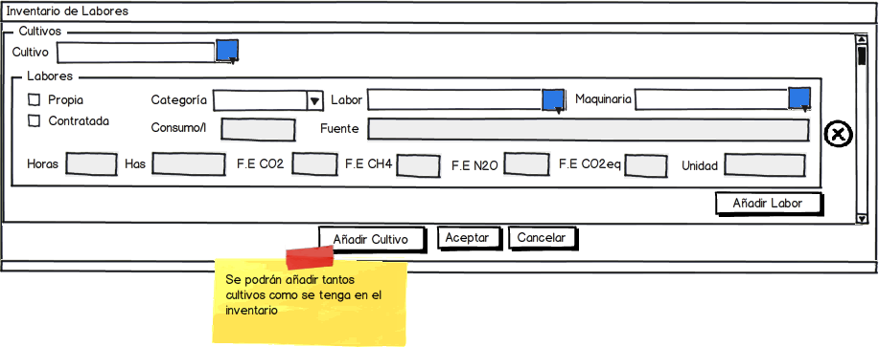

The "Consumo/h" (Consumption/h) field is auto calculated and can not be modified (Formula pending).

In the case of third parts works:

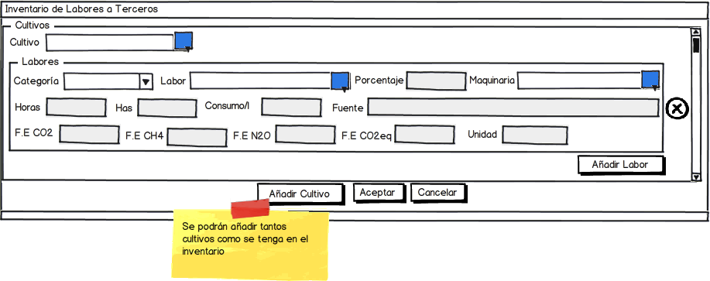

The crop selection screens, machine and work are identical to those shown so far as to selection by category screens or as inventory records.

The data stored in the database are (“empresa_labores” in spanish):

|  |  |  |
| --- | --- | --- |
| Name | Description | Permissions |
| Identificador (Identificator) | Automatically auto increment key, invisible to the user |  |
| Empresa (Enterprise) | Relation to the associated enterprise. Invisible to the user. |  |
| Es Producción (Is Production) | Equals 1 because the record is created by production menu. |  |
| Es Transformación (Is Transformation) | Equals 0 because the record isn’t created by transformation menu. |  |
| Es Propia (is Owned) | 1 if the work is owned |  |
| Es Contratada (is Hired) | 1 if the work is hired |  |
| Es terceros (is third parties) | 1 if the work is for third parties |  |
| Porcentaje (Percentage) | Decimal Data. Required if the work is for third parties. Empty in other case. |  |
| Tipo Básico (Basic Type) | Relation to the type it belongs to. Invisible to the user. |  |
| Categoría (Category) | Relation to the category it belongs to. Invisible to the user. |  |
| Cultivo (Crop) | Relation to the associated crop. Invisible to the user. |  |
| Labor (Work) | Relation to the associated work. Invisible to the user. |  |
| Maquinaria (Machinery) | Relation to the associated machinery. Invisible to the user. |  |
| Horas (Hours) | Decimal Data | Create/Modify/Delete (only on own records) |
| Hectáreas (Hectares) | Decimal Data | Create/Modify/Delete (only on own records) |
| Emisión CO2 (CO2 Emission) | Decimal data | Create/Modify/Delete (only on own records) |
| Emisión CH4 (CH4 Emission) | Decimal data | Create/Modify/Delete (only on own records) |
| Emisión N2O (NO2 Emission) | Decimal data | Create/Modify/Delete (only on own records) |
| Emisión CO2 equivalente (CO2 Equivalent Emission) | Decimal data | Create/Modify/Delete (only on own records) |
| Unidad (Unit) | Text | Create/Modify/Delete (only on own records) |
| Fuente (Source) | Text | Create/Modify/Delete (only on own records) |
| Fecha Baja (Down Date) | Will only have value if the record has been disabled |  |
| Usuario Creación Registro  (Creation User) | For the "Track". Invisible. | Only available for an administrator. It can be Listed. |
| Fecha Creación Registro  (Creation Date) | For the "Track". Invisible. | Only available for an administrator. It can be Listed. |
| Usuario Última Modificación (Last Modification User) | For the "Track". Invisible. | Only available for an administrator. It can be Listed. |
| Fecha Última Modificación (Last Modification Date) | For the "Track". Invisible. | Only available for an administrator. It can be Listed. |

#### Products

The case of the products is similar to raw materials and works, except that products together with the waste are considered the salient elements of inventories.

The resulting products of crops or animals, according to the type of enterprise can be understood as final products, and therefore, will be calculating their carbon footprint, as raw materials by a process of transformation itself. To which, also calculate its carbon footprint, only the user who will Insert the resulting value in the section on carbon footprint of the raw material corresponding.

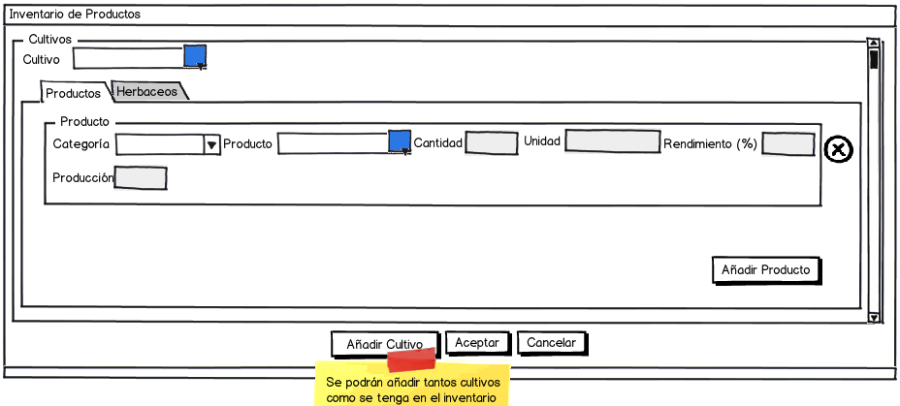

The “Producción” (Production) is calculated by by multiplying the amount with performance. Can't be modified or saved.

For herbal products:

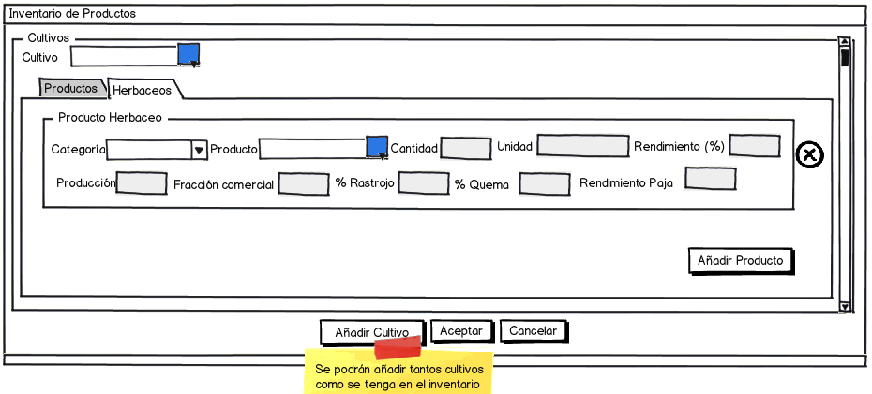

The “Rendimiento paja” (straw yield) field is calculated (formula pending). Can't be modified or saved.

The treatment remains identical the user can select as many products of their crops, such considered, taking into account the appropriate category and can select products based on this category.

(“empresa_productos_resultantes” in spanish)

|  |  |  |
| --- | --- | --- |
| Name | Description | Permissions |
| Identificador (Identificator) | Automatically auto increment key, invisible to the user |  |
| Empresa (Enterprise) | Relation to the associated enterprise. Invisible to the user. |  |
| Es Producción (Is Production) | Equals 1 because the record is created by production menu. |  |
| Es Transformación (Is Transformation) | Equals 0 because the record isn’t created by transformation menu. |  |
| Tipo Básico (Basic Type) | Relation to the type it belongs to. Invisible to the user. |  |
| Categoría (Category) | Relation to the category it belongs to. Invisible to the user. |  |
| Cultivo | Relation to the associated crop. Invisible to the user. |  |
| Producto (Product) | Relation to the associated product. Invisible to the user. |  |
| Cantidad (amount) | Decimal Data | Create/Modify/Delete (only on own records) |
| Unidad (Unit) | Text | Create/Modify/Delete (only on own records) |
| Fracción comercial (Commercial Portion) | Decimal Data | Create/Modify/Delete (only on own records) |
| Porcentaje rastrojo (Straw Percentage) | Decimal Data | Create/Modify/Delete (only on own records) |
| Porcentaje quema (Burning Percentage) | Decimal Data | Create/Modify/Delete (only on own records) |
| Fecha Baja (Down Date) | Will only have value if the record has been disabled |  |
| Usuario Creación Registro  (Creation User) | For the "Track". Invisible. | Only available for an administrator. It can be Listed. |
| Fecha Creación Registro  (Creation Date) | For the "Track". Invisible. | Only available for an administrator. It can be Listed. |
| Usuario Última Modificación (Last Modification User) | For the "Track". Invisible. | Only available for an administrator. It can be Listed. |
| Fecha Última Modificación (Last Modification Date) | For the "Track". Invisible. | Only available for an administrator. It can be Listed. |

#### Wastes and Treatment

As discussed in the previous section, are also considered waste as output elements of an inventory system.

Both crops and animals have associated waste and treatment thereof. Therefore, this example screen serves to both cases.

Regarding the Wastes, treatment of those being held apart, that is, previously to characterize the type of reside obtained, taking into account if it goes to the manager, the field or burned and the amount thereof.

On the case of your selection, involving transport, this will be indicated on the appropriate tab, indicating the type of transport the same to the manager or receiver, distance, etc.

Finally, indicate the type of treatment that will enhance on it.

The screen for the waste and its treatment (including transportation) is:

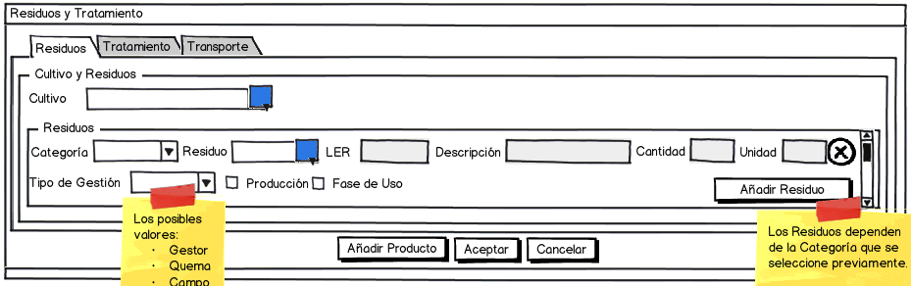

For treatment:

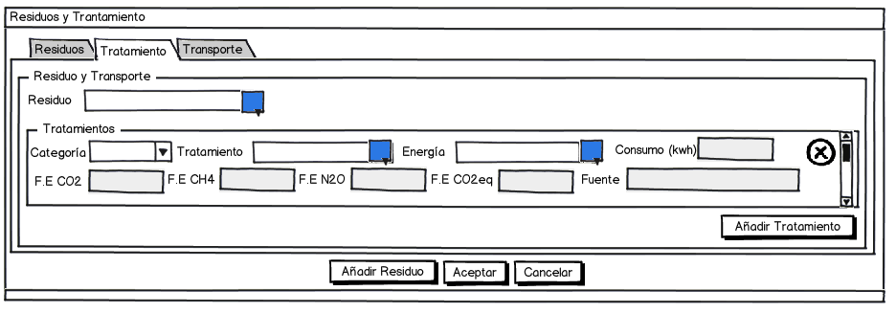

For possible transport that may be needed:

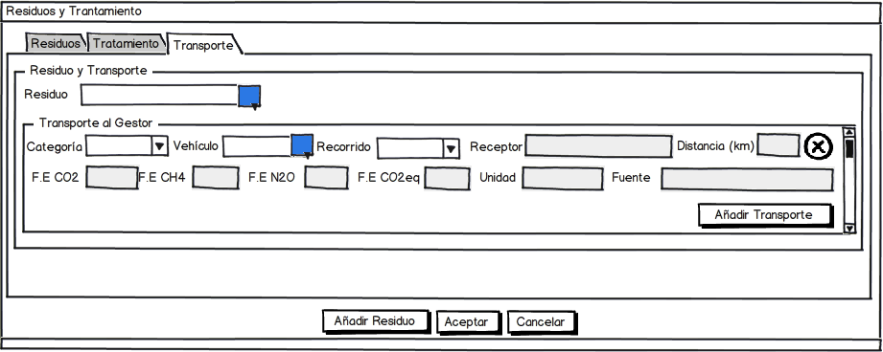

Fields must store the database are (“empresa_residuos” in spanish):

|  |  |  |
| --- | --- | --- |
| Name | Description | Permissions |
| Identificador (Identificator) | Automatically auto increment key, invisible to the user |  |
| Empresa (Enterprise) | Relation to the associated enterprise. Invisible to the user. |  |
| Es Producción (Is Production) | Equals 1 because the record is created by production menu. |  |
| Es Transformación (Is Transformation) | Equals 0 because the record isn’t created by transformation menu. |  |
| Es fase de uso (is Use phase) | Alowed values:   1. Producción 2. Fase de uso | Create/Modify/Delete (only on own records) |
| Tipo Básico (Basic Type) | Relation to the type it belongs to. Invisible to the user. |  |
| Categoría (Category) | Relation to the category it belongs to. Invisible to the user. |  |
| Cultivo (Crop) | Relation to the associated crop. Invisible to the user. |  |
| Residuo (waste) | Relation to the associated waste. Invisible to the user. |  |
| LER | Código LER | Create/Modify/Delete (only on own records) |
| Tipo de Gestión (Management Type) | Allowed values:   * Gestor * Quema * Campo | Create/Modify/Delete (only on own records) |
| Cantidad (Amount) | Decimal Data | Create/Modify/Delete (only on own records) |
| Unidad (Unit) | Text. Copy from waste master table. It can’t be modified. | Create/Modify/Delete (only on own records) |
| Descripción (Description) | Text | Create/Modify/Delete (only on own records) |
| Fecha Baja (Down Date) | Will only have value if the record has been disabled |  |
| Usuario Creación Registro  (Creation User) | For the "Track". Invisible. | Only available for an administrator. It can be Listed. |
| Fecha Creación Registro  (Creation Date) | For the "Track". Invisible. | Only available for an administrator. It can be Listed. |
| Usuario Última Modificación (Last Modification User) | For the "Track". Invisible. | Only available for an administrator. It can be Listed. |
| Fecha Última Modificación (Last Modification Date) | For the "Track". Invisible. | Only available for an administrator. It can be Listed. |
| Treatment (“empresa_residuos_tratamiento” in spanish) | |  |
| Residuo Waste) | Relation to the associated waste. Invisible to the user. |  |
| Tipo Básico (Basic Type) | Relation to the type it belongs to. Invisible to the user. |  |
| Categoría (Category) | Relation to the category it belongs to. Invisible to the user. |  |
| Tratamiento (treatment) | Relation to the associated treatment. Invisible to the user. |  |
| Energía (Energy) | Relation to the associated energy. Invisible to the user. |  |
| Emisión CO2 (CO2 Emission) | Decimal data | Create/Modify/Delete (only on own records) |
| Emisión CH4 (CH4 Emission) | Decimal data | Create/Modify/Delete (only on own records) |
| Emisión N2O (NO2 Emission) | Decimal data | Create/Modify/Delete (only on own records) |
| Emisión CO2 equivalente (CO2 Equivalent Emission) | Decimal data | Create/Modify/Delete (only on own records) |
| Unidad (Unit) | Text | Create/Modify/Delete (only on own records) |
| Fuente (Source) | Text | Create/Modify/Delete (only on own records) |
| Consumo (consumption) | Decimal Data | Crear/Modificar/Eliminar (solo sobre sus registros) |
| Transport (“empresa_residuos_transporte” in spanish) | |  |
| Residuo (Waste) | Relation to the associated waste. Invisible to the user. |  |
| Tipo Básico (Basic Type) | Relation to the type it belongs to. Invisible to the user. |  |
| Categoría (Category) | Relation to the category it belongs to. Invisible to the user. |  |
| Vehículo (Vehicle) | Relation to the associated vehicle (Machine). Invisible to the user. |  |
| Tipo Recorrido (Route) | Relation to the associated Route. Invisible to the user. | Create/Modify/Delete (only on own records) |
| Receptor (receiver) | Text | Create/Modify/Delete (only on own records) |
| Distancia (Distance) | Decimal Data | Create/Modify/Delete (only on own records) |
| Emisión CO2 (CO2 Emission) | Decimal data | Create/Modify/Delete (only on own records) |
| Emisión CH4 (CH4 Emission) | Decimal data | Create/Modify/Delete (only on own records) |
| Emisión N2O (NO2 Emission) | Decimal data | Create/Modify/Delete (only on own records) |
| Emisión CO2 equivalente (CO2 Equivalent Emission) | Decimal data | Create/Modify/Delete (only on own records) |
| Unidad (Unit) | Text | Create/Modify/Delete (only on own records) |
| Fuente (Source) | Text | Create/Modify/Delete (only on own records) |

### Animals

#### Animal Catalog

This case is similar to crop, therefore, the operation is identical the user must register its own animal in exploitation inventory, indicating the number of them, by category of animal on the farm, the cycles/square and the hours/days of grazing.

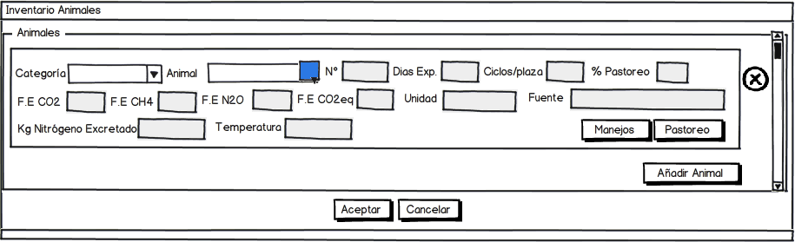

The selection of the animals was done according to the category indicated by the user.

The “Porcentaje pastoreo” (grazing Percentage) field can be calculated from the animal grazing or indicate directly if known.

Both options are incompatible with each other, so that only one of them will be saved

For handling:

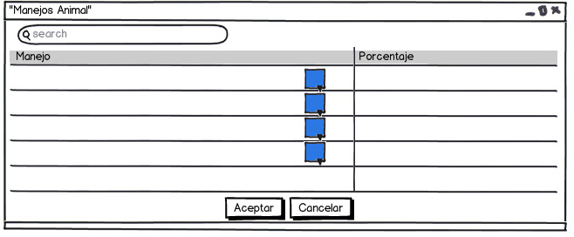

For grazing:

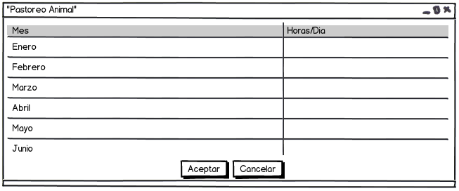

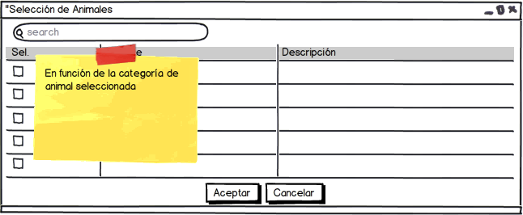

Therefore, the data stored in database are the following (“empresa_animales” in spanish):

|  |  |  |
| --- | --- | --- |
| Name | Description | Permissions |
| Identificador (Identificator) | Automatically auto increment key, invisible to the user |  |
| Empresa (Enterprise) | Relation to the associated enterprise. Invisible to the user. |  |
| Es Producción (Is Production) | Equals 1 because the record is created by production menu. |  |
| Es Transformación (Is Transformation) | Equals 0 because the record isn’t created by transformation menu. |  |
| Tipo Básico (Basic Type) | Relation to the type it belongs to. Invisible to the user. |  |
| Categoría (Category) | Relation to the category it belongs to. Invisible to the user. |  |
| Animal (Animal) | Relation to the associated animal. Invisible to the user. |  |
| Numero (number) | Numeric Data | Create/Modify/Delete (only on own records) |
| Días Explotación (Exploitation days) | Numeric Data | Create/Modify/Delete (only on own records) |
| Ciclos/plaza (Cycles/Square) | Decimal Data | Create/Modify/Delete (only on own records) |
| Horas/día Pastoreo (Grazing Hours/day) | Decimal Data | Create/Modify/Delete (only on own records) |
| Emisión CO2 (CO2 Emission) | Decimal data | Create/Modify/Delete (only on own records) |
| Emisión CH4 (CH4 Emission) | Decimal data | Create/Modify/Delete (only on own records) |
| Emisión N2O (NO2 Emission) | Decimal data | Create/Modify/Delete (only on own records) |
| Emisión CO2 equivalente (CO2 Equivalent Emission) | Decimal data | Create/Modify/Delete (only on own records) |
| Unidad (Unit) | Text | Create/Modify/Delete (only on own records) |
| Fuente (Source) | Text | Create/Modify/Delete (only on own records) |
| Fecha Baja (Down Date) | Will only have value if the record has been disabled |  |
| Usuario Creación Registro  (Creation User) | For the "Track". Invisible. | Only available for an administrator. It can be Listed. |
| Fecha Creación Registro  (Creation Date) | For the "Track". Invisible. | Only available for an administrator. It can be Listed. |
| Usuario Última Modificación (Last Modification User) | For the "Track". Invisible. | Only available for an administrator. It can be Listed. |
| Fecha Última Modificación (Last Modification Date) | For the "Track". Invisible. | Only available for an administrator. It can be Listed. |

For handling (“empresa_animales_manejos” in spanish):

|  |  |  |
| --- | --- | --- |
| Name | Description | Permissions |
| Animal (Animal) | Relation to the associated Animal. Invisible to the user. |  |
| Manejo (Handling) | Relation to the associated handlilng. Invisible to the user. |  |
| Empresa (Enterprise) | Relation to the associated enterprise. Invisible to the user. |  |
| Porcentaje (percentage) | Numeric data | Create/Modify/Delete (only on own records) |

And for grazing (“empresa_animales_pastoreo” in spanish):

|  |  |  |
| --- | --- | --- |
| Name | Description | Permissions |
| Animal (Animal) | Relation to the associated Animal. Invisible to the user. |  |
| Empresa (Enterprise) | Relation to the associated enterprise. Invisible to the user. |  |
| Enero (January) | Decimal Data | Create/Modify/Delete (only on own records) |
| Febrero (February) | Decimal Data | Create/Modify/Delete (only on own records) |
| Marzo (March) | Decimal Data | Create/Modify/Delete (only on own records) |
| Abril (April) | Decimal Data | Create/Modify/Delete (only on own records) |
| Mayo (May) | Decimal Data | Create/Modify/Delete (only on own records) |
| Junio (June) | Decimal Data | Create/Modify/Delete (only on own records) |
| Julio (July) | Decimal Data | Create/Modify/Delete (only on own records) |
| Agosto (August) | Decimal Data | Create/Modify/Delete (only on own records) |
| Septiembre (September) | Decimal Data | Create/Modify/Delete (only on own records) |
| Octubre (October) | Decimal Data | Create/Modify/Delete (only on own records) |
| Noviembre (November) | Decimal Data | Create/Modify/Delete (only on own records) |
| Diciembre (December) | Decimal Data | Create/Modify/Delete (only on own records) |
| Usuario Creación Registro  (Creation User) | For the "Track". Invisible. | Only available for an administrator. It can be Listed. |
| Fecha Creación Registro  (Creation Date) | For the "Track". Invisible. | Only available for an administrator. It can be Listed. |
| Usuario Última Modificación (Last Modification User) | For the "Track". Invisible. | Only available for an administrator. It can be Listed. |
| Fecha Última Modificación (Last Modification Date) | For the "Track". Invisible. | Only available for an administrator. It can be Listed. |

**Example of calculations for sheep.**

**- Calculate the average annual population: (Number of animals x days in the exploitation) / 365**

**- Grazing: Each month should be input the number of hours a day grazing (eg January: 7/24, etc.). After entering the number of hours for the 12 months calculate the annual average grazing (Sum of January through December) / 12/24)).**

**- The animal has a percentage of N, P and K on the average weight (kg) of animal and depending on the province in which the company is located, the animal has an associated excreted percentage. Calculate the N-P2O5-K2O excreted annually in the farm. (No. of animals x kg (N-P2O5-K2O) / head and year)), where Kg P2O5-K2O-N is calculated by multiplying the weight of the animal, the percentages of NPK by the percentage of excreted**. **In case of indicating value of UGM this value is used instead of head-year**

**- Methodology for the calculation of nitrogen managed annually: (knowing how to handle / manage livestock waste on the farm).** **To do this: 1 - As previously calculated the percentage of annual grazing, nitrogen is calculated annually by managed grazing. Multiplying the Ntotal excreted annually by the percentage of grazing (for each animal category). Then add up all the categories to calculate the annual nitrogen in the exploitation managed by grazing.**

**- After calculating the N. managed by grazing, we have to calculate the Ngestionado by other management. Remember that the handlings will be similar / different depending on the animal category studied.**

**- The user enters the percentage of remaining management manipulations on the exploitation. Remember that the total should be equal to 100%, which must enable a function to notify user when this is left above or below the 100%.**

**- Thus finally know the kilograms of N excreted annually for all animal categories on the exploitation and the% nitrogen managed by different methods (which must equal the amount excreted).**

**- Enteric fermentation: for each category of animal enteric fermentation is calculated by multiplying the number of animals in each category by the specific emission factor. The FE Total is the sum of the individual category.**

**- Manure Management**

**- CH4 emissions: compost management will depend on the temperature (T th) of the municipality where the exploitation is under study. To calculate the kg/CH4/anual issued by the management of compost is calculated by multiplying the number of animals by their respective category emission factor. The total is the sum of the kg/CH4/year calculated for each category.**

**- Calculation of N2O emissions from manure management: Previously calculated the total nitrogen excreted in the exploitation and its management or administration (through grazing and other management). In the case of N2O emissions from manure management shall be exclusively at the nitrogen excreted by other management (ie, not taken into account the N excreted by grazing).**

#### Raw Materials

In the same way as for crops, animal inventories, the user can select the corresponding animal and associate a series of raw materials, along with the displacement corresponding to the exploitation.

(“empresa_materias_primas” in spanish):

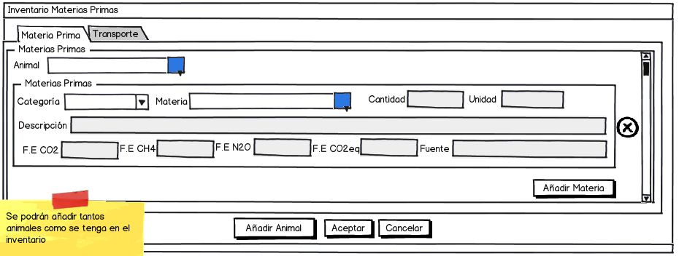

(“empresa_materias_primas_transporte” in spanish):



#### Products

The behavior of the tool at this point is similar to the previous section for the crops.

#### Waste and Treatment

The screen corresponding to this point is identical to the case of crops. In this case, an animal is selected from among those discharged from the inventory of exploitation.

### Machines

#### Machine Catalog

The production enterprise user has the option to list the machines on which it counts in its exploitation.

Selecting an appropriate category can select the machine that fits that category.

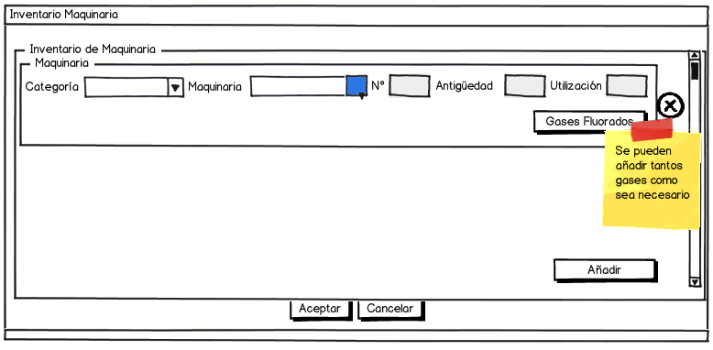

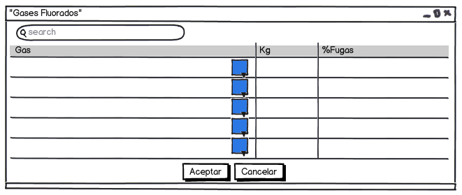

The selection of the machine may only be made among those that have been previously created. The selection screen is as follows:

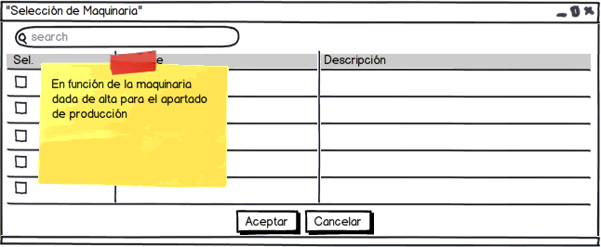

(“empresa_maquinarias” in spanish):

|  |  |  |
| --- | --- | --- |
| Name | Description | Permissions |
| Identificador (Identificator) | Automatically auto increment key, invisible to the user |  |
| Es Producción (Is Production) | Equals 1 because the record is created by production menu. |  |
| Es Transformación (Is Transformation) | Equals 0 because the record isn’t created by transformation menu. |  |
| Empresa (Enterprise) | Relation to the associated enterprise. Invisible to the user. |  |
| Tipo Básico (Basic Type) | Relation to the type it belongs to. Invisible to the user. |  |
| Categoría (Category) | Relation to the category it belongs to. Invisible to the user. |  |
| Maquinaria (Machinery) | Relation to the associated machinery. Invisible to the user. |  |
| Número (Number) | Numeric data | Create/Modify/Delete (only on own records) |
| Antigüedad (antiquity) | Decimal Data | Create/Modify/Delete (only on own records) |
| Utilización (Utilization) | Text | Create/Modify/Delete (only on own records) |
| Fecha Baja (Down Date) | Will only have value if the record has been disabled |  |
| Usuario Creación Registro  (Creation User) | For the "Track". Invisible. | Only available for an administrator. It can be Listed. |
| Fecha Creación Registro  (Creation Date) | For the "Track". Invisible. | Only available for an administrator. It can be Listed. |
| Usuario Última Modificación (Last Modification User) | For the "Track". Invisible. | Only available for an administrator. It can be Listed. |
| Fecha Última Modificación (Last Modification Date) | For the "Track". Invisible. | Only available for an administrator. It can be Listed. |

Para los gases fluorados de la máquina (“empresa_maquinarias_gases_fluorados” in spanish):

|  |  |  |
| --- | --- | --- |
| Name | Description | Permissions |
| Maquinaria (Machinery) | Relation to the associated Machinery. Invisible to the user. |  |
| Empresa (Enterprise) | Relation to the associated enterprise. Invisible to the user. |  |
| Gas | Relation to the associated gas. Invisible to the user. |  |
| Kg Gas | Decimal Data | Create/Modify/Delete (only on own records) |
| Porcentaje Fugas (Leak percentage) | Decimal Data | Create/Modify/Delete (only on own records) |
| Fecha Baja (Down Date) | Will only have value if the record has been disabled |  |
| Usuario Creación Registro  (Creation User) | For the "Track". Invisible. | Only available for an administrator. It can be Listed. |
| Fecha Creación Registro  (Creation Date) | For the "Track". Invisible. | Only available for an administrator. It can be Listed. |
| Usuario Última Modificación (Last Modification User) | For the "Track". Invisible. | Only available for an administrator. It can be Listed. |
| Fecha Última Modificación (Last Modification Date) | For the "Track". Invisible. | Only available for an administrator. It can be Listed. |

### Installations

#### Installations Catalog

As same as machinery, in the case of installations also be able to list the exploitation installations.

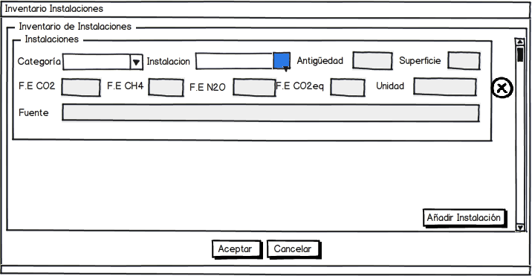

Similarly, after selecting the category, the user by clicking the blue button can select installations which are created in system.

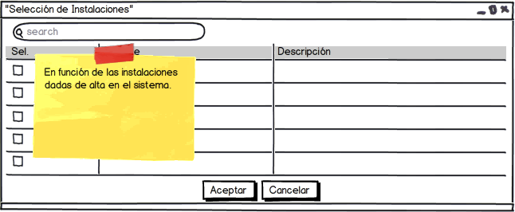

The data stored in system database includes both relationships between the various elements, such as data required to characterize.

(“empresa_instalaciones” in spanish):

|  |  |  |
| --- | --- | --- |
| Name | Description | Permissions |
| Identificador (Identificator) | Automatically auto increment key, invisible to the user |  |
| Empresa (Enterprise) | Relation to the associated enterprise. Invisible to the user. |  |
| Es Producción (Is Production) | Equals 1 because the record is created by production menu. |  |
| Es Transformación (Is Transformation) | Equals 0 because the record isn’t created by transformation menu. |  |
| Tipo Básico (Basic Type) | Relation to the type it belongs to. Invisible to the user. |  |
| Categoría (Category) | Relation to the category it belongs to. Invisible to the user. |  |
| Instalación (Instalation) | Relation to the associated instalation. Invisible to the user. |  |
| Superficie (surface) | Decimal Data | Create/Modify/Delete (only on own records) |
| Antigüedad (antiquity) | Decimal Data | Create/Modify/Delete (only on own records) |
| Emisión CO2 (CO2 Emission) | Decimal Data | Create/Modify/Delete (only on own records) |
| Emisión CH4 (CH4 Emission) | Decimal Data | Create/Modify/Delete (only on own records) |
| Emisión N2O (NO2 Emission) | Decimal Data | Create/Modify/Delete (only on own records) |
| Emisión CO2 equivalente (CO2 Equivalent Emission) | Decimal Data | Create/Modify/Delete (only on own records) |
| Unidad (Unit) | Text | Create/Modify/Delete (only on own records) |
| Fuente (Source) | Text | Create/Modify/Delete (only on own records) |
| Fecha Baja (Down Date) | Will only have value if the record has been disabled |  |
| Usuario Creación Registro  (Creation User) | For the "Track". Invisible. | Only available for an administrator. It can be Listed. |
| Fecha Creación Registro  (Creation Date) | For the "Track". Invisible. | Only available for an administrator. It can be Listed. |
| Usuario Última Modificación (Last Modification User) | For the "Track". Invisible. | Only available for an administrator. It can be Listed. |
| Fecha Última Modificación (Last Modification Date) | For the "Track". Invisible. | Only available for an administrator. It can be Listed. |

### Energy

#### Energy catalog

It’s similar to previous cases. Properties screen is shown below:

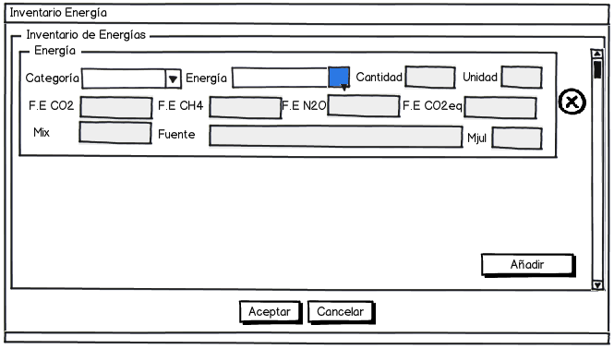

The energy selection is made ​​according to the category indicated by the user.

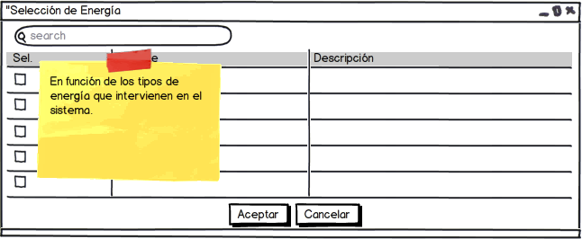

The data should be stored in the database, including both the relationships between the various elements, and the data necessary to characterize.

(“empresa_energias” in spanish):

|  |  |  |
| --- | --- | --- |
| Name | Description | Permissions |
| Identificador (Identificator) | Automatically auto increment key, invisible to the user |  |
| Empresa (Enterprise) | Relation to the associated enterprise. Invisible to the user. |  |
| Es Producción (Is Production) | Equals 1 because the record is created by production menu. |  |
| Es Transformación (Is Transformation) | Equals 0 because the record isn’t created by transformation menu. |  |
| Tipo Básico (Basic Type) | Relation to the type it belongs to. Invisible to the user. |  |
| Categoría (Category) | Relation to the category it belongs to. Invisible to the user. |  |
| Energía (Energy) | Relation to the associated energy. Invisible to the user. |  |
| Cantidad (amount) | Decimal Data | Create/Modify/Delete (only on own records) |
| Unidad (Unit) | Text | Create/Modify/Delete (only on own records) |
| Mix | Text | Create/Modify/Delete (only on own records) |
| Mjul | Decimal Data | Create/Modify/Delete (only on own records) |
| Emisión CO2 (CO2 Emission) | Decimal data | Create/Modify/Delete (only on own records) |
| Emisión CH4 (CH4 Emission) | Decimal data | Create/Modify/Delete (only on own records) |
| Emisión N2O (NO2 Emission) | Decimal data | Create/Modify/Delete (only on own records) |
| Emisión CO2 equivalente (CO2 Equivalent Emission) | Decimal data | Create/Modify/Delete (only on own records) |
| Fuente (Source) | Text | Create/Modify/Delete (only on own records) |
| Fecha Baja (Down Date) | Will only have value if the record has been disabled |  |
| Usuario Creación Registro  (Creation User) | For the "Track". Invisible. | Only available for an administrator. It can be Listed. |
| Fecha Creación Registro  (Creation Date) | For the "Track". Invisible. | Only available for an administrator. It can be Listed. |
| Usuario Última Modificación (Last Modification User) | For the "Track". Invisible. | Only available for an administrator. It can be Listed. |
| Fecha Última Modificación (Last Modification Date) | For the "Track". Invisible. | Only available for an administrator. It can be Listed. |

* **CO2 emissions from electricity consumption at the exploitation: emissions depend on the year and electricity supplier. Depending the year multiply the kwh consumed entered by the user by their respective emission factor.** **Keep in mind that in the case of electricity would be speaking the scope 1 and 2. When using emission factors from the mixture of Spanish power system is assumed to incorporate both scope and in its calculations.**

### Auxiliary Services

#### Auxiliary Services Catalog

As in other previous cases, auxiliary services also may be listed. The proof is the properties window, where the user selects a category and then a service that is encompassed in that category. Then, must indicate the type of energy it needs and the percentage of consumption of the same, together with a percentage of electricity consumption.

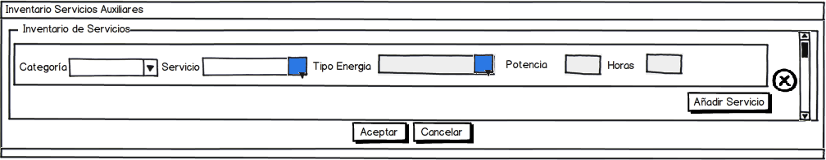

The selection screen of auxiliary services is similar to the type of energy that may come to associate with the selected service.

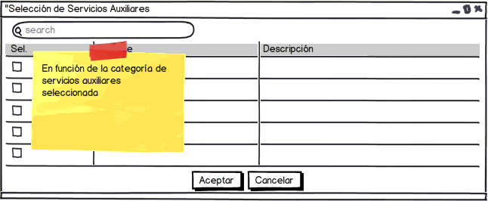

(“empresa_servicios_auxiliares” in spanish):

|  |  |  |
| --- | --- | --- |
| Name | Description | Permissions |
| Identificador (Identificator) | Automatically auto increment key, invisible to the user |  |
| Empresa (Enterprise) | Relation to the associated enterprise. Invisible to the user. |  |
| Es Producción (Is Production) | Equals 1 because the record is created by production menu. |  |
| Es Transformación (Is Transformation) | Equals 0 because the record isn’t created by transformation menu. |  |
| Tipo Básico (Basic Type) | Relation to the type it belongs to. Invisible to the user. |  |
| Categoría (Category) | Relation to the category it belongs to. Invisible to the user. |  |
| Servicio Auxiliar | Identificador. Invisible al usuario |  |
| Energía | Identificador, Invisible al usuario |  |
| Potencia (Power) | Decimal Data | Create/Modify/Delete (only on own records) |
| Horas (Hours) | Decimal Data | Create/Modify/Delete (only on own records) |
| Fecha Baja (Down Date) | Will only have value if the record has been disabled |  |
| Usuario Creación Registro  (Creation User) | For the "Track". Invisible. | Only available for an administrator. It can be Listed. |
| Fecha Creación Registro  (Creation Date) | For the "Track". Invisible. | Only available for an administrator. It can be Listed. |
| Usuario Última Modificación (Last Modification User) | For the "Track". Invisible. | Only available for an administrator. It can be Listed. |
| Fecha Última Modificación (Last Modification Date) | For the "Track". Invisible. | Only available for an administrator. It can be Listed. |

### Consumables

#### Consumables Catalog

Consumables may be associated with a vehicle and/or distance. Therefore, the user will indicate the corresponding consumable category together with the selection thereof after the elements selection screen shown later.

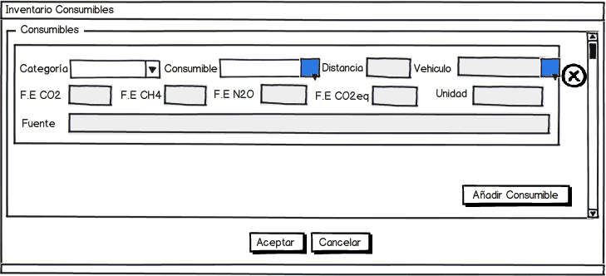

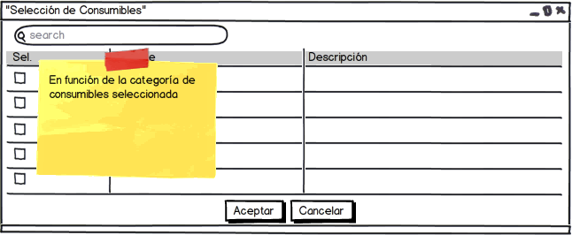

The following table shows the data input (“empresa_consumibles” in spanish):

|  |  |  |
| --- | --- | --- |
| Name | Description | Permissions |
| Identificador (Identificator) | Automatically auto increment key, invisible to the user |  |
| Empresa (Enterprise) | Relation to the associated enterprise. Invisible to the user. |  |
| Es Producción (Is Production) | Equals 1 because the record is created by production menu. |  |
| Es Transformación (Is Transformation) | Equals 0 because the record isn’t created by transformation menu. |  |
| Tipo Básico (Basic Type) | Relation to the type it belongs to. Invisible to the user. |  |
| Categoría (Category) | Relation to the category it belongs to. Invisible to the user. |  |
| Consumible (Consumable) | Relation to the associated consumable. Invisible to the user. |  |
| Vehículo (Vehicle) | Relation to the associated vehicle (machine). Invisible to the user. |  |
| Distancia (Distance) | Decimal data | Create/Modify/Delete (only on own records) |
| Emisión CO2 (CO2 Emission) | Decimal data | Create/Modify/Delete (only on own records) |
| Emisión CH4 (CH4 Emission) | Decimal data | Create/Modify/Delete (only on own records) |
| Emisión N2O (NO2 Emission) | Decimal data | Create/Modify/Delete (only on own records) |
| Emisión CO2 equivalente (CO2 Equivalent Emission) | Decimal data | Create/Modify/Delete (only on own records) |
| Unidad (Unit) | Text | Create/Modify/Delete (only on own records) |
| Fuente (Source) | Text | Create/Modify/Delete (only on own records) |
| Fecha Baja (Down Date) | Will only have value if the record has been disabled |  |
| Usuario Creación Registro  (Creation User) | For the "Track". Invisible. | Only available for an administrator. It can be Listed. |
| Fecha Creación Registro  (Creation Date) | For the "Track". Invisible. | Only available for an administrator. It can be Listed. |
| Usuario Última Modificación (Last Modification User) | For the "Track". Invisible. | Only available for an administrator. It can be Listed. |
| Fecha Última Modificación (Last Modification Date) | For the "Track". Invisible. | Only available for an administrator. It can be Listed. |

## Transformation

In this menu, the user will indicate the processes involved in the development of the industrial transformation of final products, or also called, functional units.

The menu has the options to identify the processes or products according the industry works. In addition, determines the treatment that will follow the waste.

There is the option to make an inventory or catalog of both: Facilities and energy as ancillary services as consumables.

All records created from the “Transformación” (Transformation) menu will have the “Es Transformación” (Is Transformation) field = 1 and the "Is Producción" (Is Production) field = 0 (In contrast to records created from the production menu).

The formulas given for transformation are valid for production (all follow the same calculation philosophy).

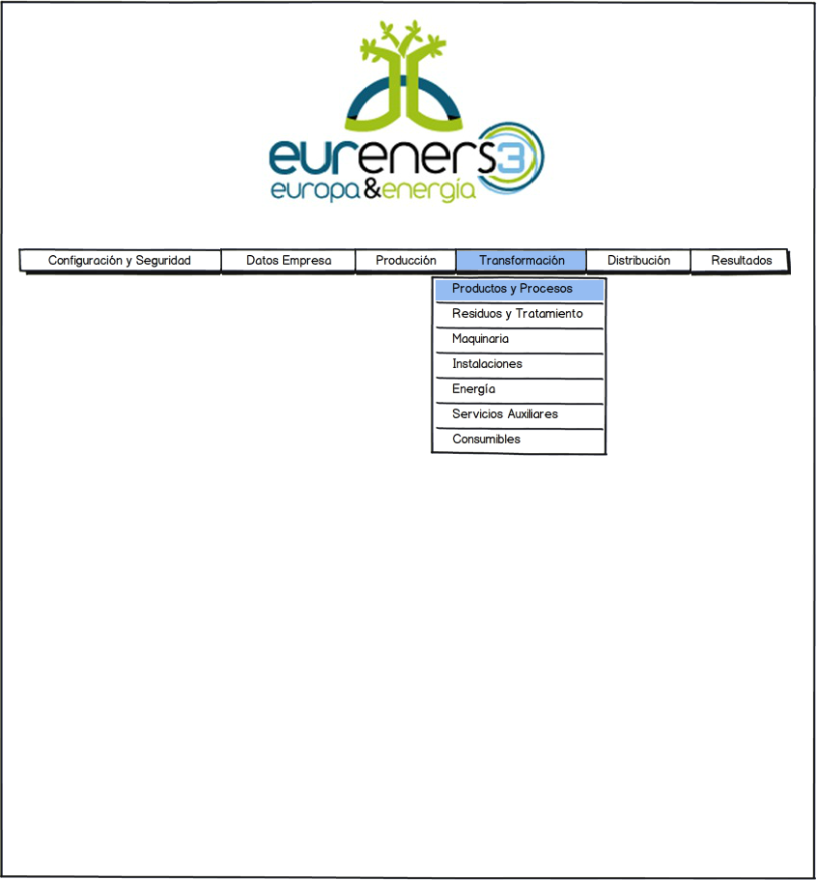

### Products and Processes

Products that can be selected in the drop-down enabled, will recover from those indicated in the initial setup screen of the enterprise.

The calculation of the energy of each process depends on the hours and the power of the machinery employed in each thread. It is therefore necessary to indicate this data, or indicate a percentage of the same.

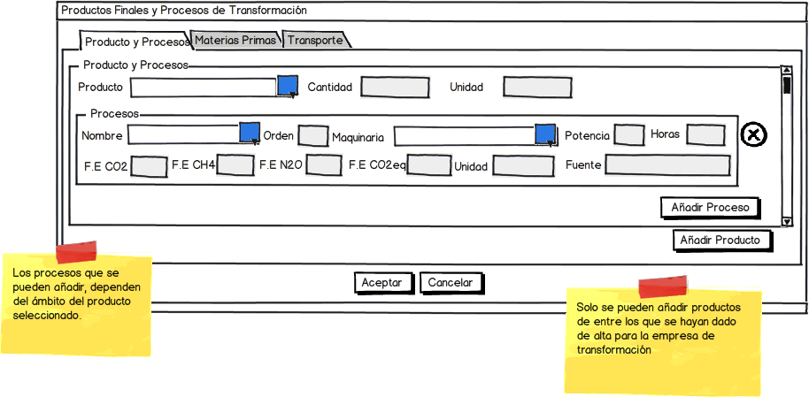

The “Unidad” (Unit) field will automatically load from the master of final products. Can’t be modified.

**To calculate the carbon footprint from the energy consumed in each process is the following operation:**

**CO2 ENERGY = Power (entered by the user) x hours (user) x CO2 emission factor (energy master table and the type energy considered).**

**The formula is the same for CH4 and N2O.**

**IMPORTANT: When calculating the energy consumption as a result of the power and number of hours the program will perform the summation of all processes introduced and auxiliary services and compare the total energy introduced by the user so that doesn’t give as the distribution must be recalculated by the processes to which of the user**.

For each product, the user can indicate the raw materials used globally. Not necessary to lower the level of detail of each thread as it may influence the optimal estimate the carbon footprint of the final product. In the case of raw materials, if you know their carbon footprint would need to enter to be taken into account when being added to the final calculation. In addition, for each raw material is necessary to give the vehicle and the travel distance.

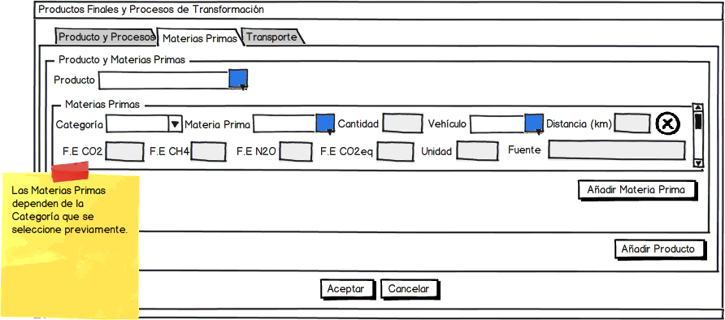

**For calculating the carbon footprint from the raw material consumed in processing is the next operation:**

**CO2 CONSUMPTION = AMOUNT (entered by the user) x CO2 emission factor (master table of raw materials).**

**CO2 TRANSPORT = DISTANCE (user) x CO2 emission factor (master table and vehicles according to vehicle type and journey in question)**.

**CO2 TOTAL = CO2 CONSUMPTION + CO2 TRANSPORT**

**The formula is the same to CH4 and N2O.**

For transport:

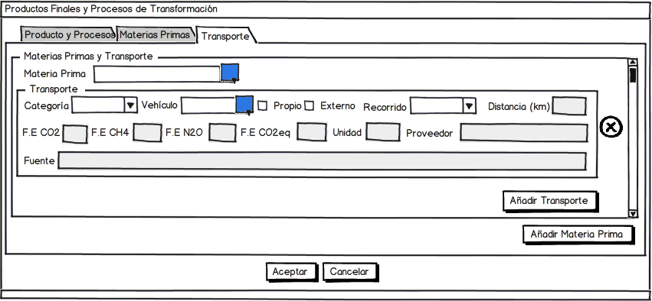

### Waste and Treatment

In this section the user will select the type of waste generated, associate them to a product along with its category, LER code, Quantity and unit.

#### Wastes

For each product, may have one or more residues, for each of these residues must indicate the type of management that should be done with it: Manager, Burning or Field.

In this way, may indicate whether this waste is associated with a transport to a management company thereof. For this case, many routes may be added as needed as many managers as involved in the development.

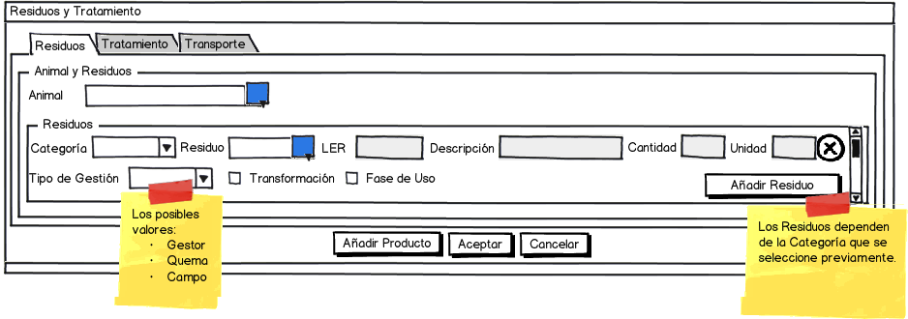

#### Treatment

This section depends on the type of waste management.

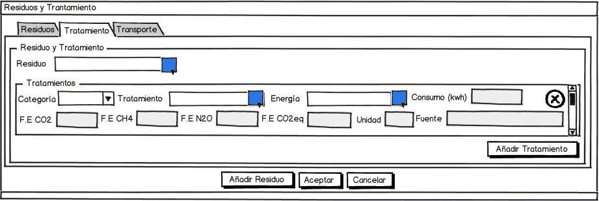

#### Transport

It depends of the type of management. The corresponding screen is as follows:

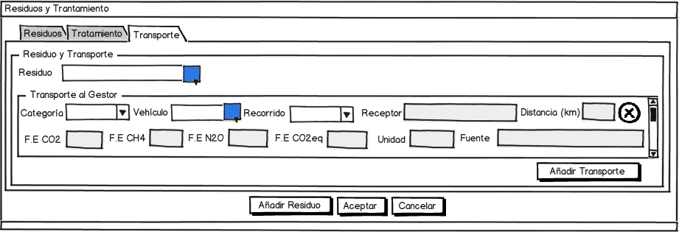

User can indicate the type of vehicles that are transported the waste to the manager or to another holding, etc.

### Machines

#### Machine Catalog

This section, together with its screen is identical to the catalog section of production machinery, except that the machinery that can be selected here. These will be who are discharged in system and indicated as manufacturing industry machinery.

**Emissions from the production of machinery are calculated:**

**MACHINERY CO2 = AMOUNT (entered by the user) x CO2 emission factor (machines master table) / YEARS OLD (user).**

**The formula is the same to CH4 and N2O.**

**CO2-eq REFRIGERANT LEAK = COOLING LOAD (user) x% LEAK (user) x Emission Factor CO2-eq (Master Table of gases).**

**In this case only leak is calculated CO2-eq and no breakdown of CO2, CH4, N2O Installations**

#### Installations Catalog

Just as in the previous section, both the screen and the selection of installations will depend on the category of those that are created for the manufacturing industry.

**Emissions from installations shall be calculated:**

**CO2 INSTALLATION = SURFACE INSTALLATION (entered by the user) x CO2 emission factor (installations master table) / ANTIQUITY (user).**

**The formula is the same for CH4 and N2O.**

### Energy

#### Energy Catalog

In this case, the list of the energy involved in the transformation process does not depend on section of the system where the user is.

**To calculate the carbon footprint from the energy consumed in each auxiliary service is the next operation:**

**AUXILIARY SERVICE CO2 = Power (entered by the user) x hours (user) x CO2 emission factor (energy master table of the type energy considered).**

**The formula is the same for CH4 and N2O.**

**IMPORTANT: When calculating the energy consumption as a result of the power and number of hours the program will perform the summation of all processes introduced and auxiliary services and compare the total energy introduced by the user so that doesn't give as the distribution must be recalculated by the processes to which the total to the user.**

### Auxiliary Services

#### Auxiliary Services Catalog

Identical to the production section the user identifies the auxiliary service with which is working.

### Consumables

#### Consumables Catalog

Similarly that in point of production, the user must indicate the type of consumable and select it from a list.

**To calculate the carbon footprint from the supplies in the transformation is the following operation:**

**CO2 CONSUMPTION = AMOUNT (entered by the user) x CO2 emission factor (consumables master table).**

**CO2 TRANSPORT = DISTANCE (user) x CO2 emission factor (master table and vehicles according to vehicle type and journey in question).**

**Total CO2 = CO2 CONSUMPTION + CO2 TRANSPORT**

**The formula is the same for CH4 and N2O.**

## Distribution

### Transport or Product distribution

This menu only includes the option to list the necessary product transport to within its natural distribution or commercialized.

At this point must be indicated the transportation of final product, whatever form to the receiving entity.

The process consists of selecting a vehicle type, a mode, a receiver and a distance.

It may add as many transports as involved in the process.

The subsequent calculation of the footprint is accomplished considering the FE of the vehicle, depending on the traveled distance.

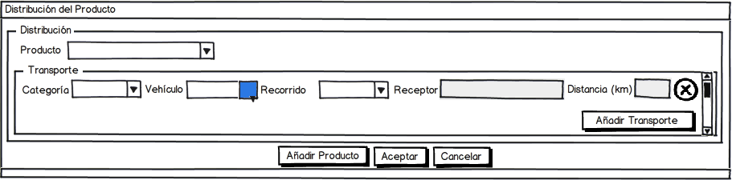

The vehicle selection is made ​​based on previously are created into the system and belong to the transport vehicle type.

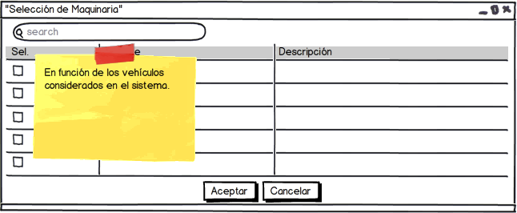

**To calculate the carbon footprint from transport from the factory to distribution center and trade is the next operation:**

**CO2 TRANSPORT = DISTANCE (user) x CO2 emission factor (vehicles master table according to vehicle type and journey in question).**

**The formula is the same for CH4 and N2O and for each transport.**

### Storage

**For calculating the footprint of carbon from each product storage considered is the next operation:**

**CO2 Storage = PRODUCT AMOUNT (user) x CO2 emission factor (corresponding to the distribution center, trade and use phase of the master table of products).**

**This calculation is applied according to the types of storage are selected on the screen of distribution transport, so that if two transports have been made for distribution centers and one for trade, will be twice the emission factors center distribution and a trade and if there is no distribution center will be used only emission factors for commercial storage.**

**The formula is the same for CH4 and N2O for storage.**

### Phase Use

**At this point are considered emissions from product use by consumers.**

**To calculate the carbon footprint for the use phase of the product under review is the following operation:**

**PHASE OF USE CO2 = PRODUCT AMOUNT (user) x CO2 emission factor (for use phase of the master table of products).**

**The formula is the same for CH4 and N2O, and for each storage.**

## Results

Data from Phase Emission Factors of Use are contained in the master data of the final products. Therefore they are included on his properties screen.

The corresponding menu item is:

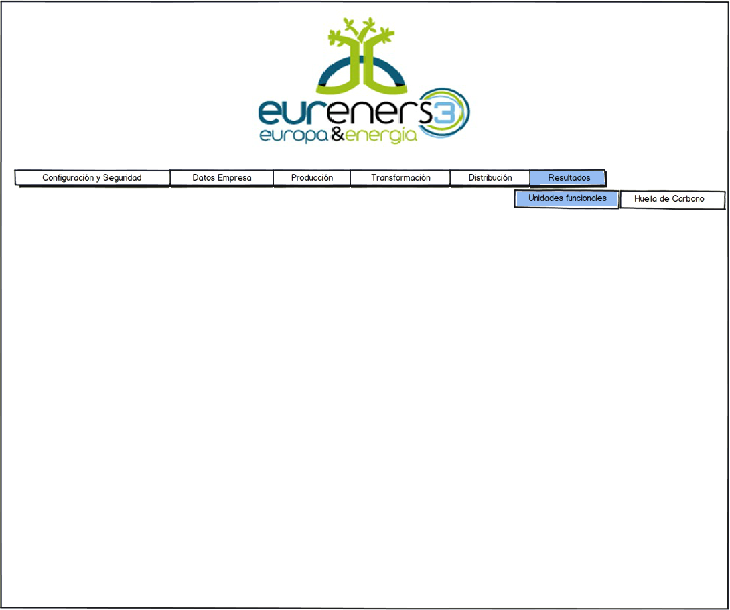

From the results tab the user can access to calculations results of carbon footprint of its functional units. To do this, from the selection screen of the functional units can select one and click the button "View Results".

The results of calculations of carbon footprint will be shown in such report as an schematic report explaining the used data.

## Calculating Carbon Footprint

The calculation of the carbon footprint is to be performed according to the different phases which are submitted the final product, seen on the screen of enterprise properties. It is important that the enterprise user or administrator user indicate these products from the beginning.

Each of the items of master data contains a series of emission factors involved in the calculation process.

It is first necessary to indicate correctly the product that will make the study of carbon footprint. Once indicated on the properties screen, it's then regarded as a functional unit of the system and so on it and the elements involved its development, will calculate its footprint.

A consensus is needed in the way in how to display data.

Be distinguish the emissions of CH4, CO2 and N2O when there are sufficient data, otherwise only be used CO2 eq emissions (CO2 equivalent).

The final emissions for each residue and treatment will be obtained from:

Multiply the value of CH4 and N2O emissions by the equivalent of CO2 (GWP of the table field gas for the gas in question) and add together the value of CO2. Multiply the result of previous operations in the amount or distance, as appropriate. If only know the value of CO2 eq multiplied by the quantity or distance.

### Overall results by product

**Separated by categories:**

* **Raw materials. Total sum calculation of production of raw materials. Formula CO2 consumption (products and processes), excluding transportation. The result should be for each considered GHG's (CO2, CH4 and N2O) and total CO2-eq.**
* **Energy. Total sum of all energy calculations used in the different processes and auxiliary services. CO2 Energy Formula (products and processes) + Co2 Auxiliary Service Formula (ancillary services). The result should be for each considered GHG's (CO2, CH4 and N2O) and the total CO2-eq.**
* **Transport. Total sum of the calculations for the transportation of raw materials, product distribution center, commerce and consumables. Co2 Transportation Formula (products and processes) + CO2 Transport Formula (consumables catalog) + Co2 Transportation Formula (Transportation or distribution of the product). The result should be for each considered GHG's (CO2, CH4 and N2O) and the total CO2-eq.**
* **Consumables. Total sum of the calculations of production of consumables. Co2 Consumption Formula (catalog consumables), excluding transportation. The result should be for each considered GHG's (CO2, CH4 and N2O) and the total CO2-eq.**
* **Machinery. Total sum of calculations for each machine. Machinery Co2 Formula (Catalogue of machinery). Not count toward the calculation of the PAS 2050. The result should be for each considered GHG's (CO2, CH4 and N2O) and the total CO2-eq.**
* **Fugitive emissions. Total sum calculations of refrigerant leaks. Coolant Leak Co2 eq Formula (Catalogue machinery). This value if computed for the PAS 2050. Be gives only the total result in CO2-eq.**
* **Installations. Sum total of calculations for each installation. Co2 Installation Formula (Installations). Not count toward the calculation of the PAS 2050. The result should be for each considered GHG's (CO2, CH4 and N2O) and the total CO2-eq.**
* **Storage. Sum total of the calculations for the storage of the product outside the industry (distribution center, trade). Co2 Storage Formula (Storage). The result should be for each considered GHG's (CO2, CH4 and N2O) and the total CO2-eq.**
* **Use Phase. Total sum calculation for the use phase of the products. Co2 Use phase Formula (Phase Use). The result should be for each considered GHG's (CO2, CH4 and N2O) and the total CO2-eq.**

### Results by Category

**At this point emissions are grouped into categories and are given for each product.**

#### Raw Materials

**Results for raw materials and broken down in production and transportation**

* **Production: CO2 consumption Formula (products and processes).**
* **Transport: CO2 Transport Formula (products and processes)**

**The result should be given for the total CO2-eq.**

#### Energy

**Results energy type and consumption types**

* **Processes: Co2 Energy Formula (products and processes).**
* **Auxiliary Services: Co2 Auxiliary Service Formula (Auxiliary Services).**
* **Transportation: In case there own company transport, sum of the calculations for transport of raw materials, consumables and products that have been made with such transportation. Co2 Formula Transportation (products and processes) + CO2 Transport Formula (consumables catalog) + CO2 transport Formula (transport or distribution of the product).**
* **By type of energy: Sum of calculations for each separate energy type (natural gas, electricity, etc.). CO2 Energy Formula (products and processes) + CO2 Auxiliary Services Formula (Auxiliary Services).**

**The result should be given for the total CO2-eq.**

#### Transport

**Results disaggregated by type**

* **Raw materials: CO2 Transport formula (products and processes).**
* **Consumables: Co2 Transport Formula (consumables catalog).**
* **Distribution Center: CO2 Transport Formula (transport or distribution of the product).**
* **Trade: CO2 Transport Formula (transport or distribution of the product).**

**The result should be given for the total CO2-eq.**

#### Consumables

**Results for consumable and breakdown in production and transport**

* **Production: Co2 Consumption Formula (Consumables).**
* **Transport: Co2 Transport formula (Consumables)**

**The result should be given for the total CO2-eq.**

#### Machinery

**Results for machinery and broken down into production and fugitive emissions**

* **Production: Co2 Machinery Formula (Catalogue of machinery)**
* **Fugitive emissions: CO2 eq Coolant Leak Formula (Catalogue of machinery).**

**The result should be given for the total CO2-eq.**

#### Installations

**Results by installation**

* **Installation: Co2 Installation Formula (Installations).**

**The result should be given for the total CO2-eq.**

#### Storage

**Results by type**

* **Distribution center: Co2 Storage Formula (Storage).**
* **Trade: Co2 Storage Fórmula (Storage).**

**The result should be given for the total CO2-eq.**

#### Use phase

* **Co2 Use phase Formula (Use phase).**

**The result should be given for the total CO2-eq.**

### Results by scope

**Emissions grouped by scope type and will reach for each product.**

#### Scope 1

**Are direct emissions from the company. Results disaggregated by type.**

* **Process: Co2 Energy Formula (Products and process). All energies except electrical.**
* **Auxiliary services: Co2 Auxiliary Service formula (Auxiliary Services). All energies except electrical.**
* **Transport (If the company's own). CO2 Transport formula (Product y process) + CO2 Transport Formula (Consumables Catalog) + CO2 Transport Formula (Transport or product distribution). All energies except electrical.**
* **Fugitive emissions: CO2 eq coolant leak Formula (Catalogue of machinery)**

**The result should be for each considered GHG's (CO2, CH4 and N2O) and the total CO2-eq.**

#### Scope 2

**Are the emissions from the production of electricity. Results disaggregated by type.**

* **Process: CO2 Energy Formula (Products and process). Electric power.**
* **Auxiliary Services: CO2 Auxiliary Service Formula (Auxiliary Services). Electric power.**
* **Transport (If the company's own). CO2 Machinery Formula (Machinery Catalog) + CO2 Transport Formula (Consumables catalog) + CO2 Transport Formula (Transport or product distribution). Electric power.**

**The result should be for each considered GHG's (CO2, CH4 and N2O) and the total CO2-eq.**

#### Scope 3

**Indirect emissions of the company and the remaining not considered in the scope 1 and 2. Results disaggregated by type.**

* **Raw materials: CO2 Consumption Formula (Products and process).**
* **Transport. CO2 Transport Formula (Products and process + CO2 Transport Formula (Consumables catalog) + CO2 Transport Formula (Transport or product distribution) in cases where the vehicles are not own the company.**
* **Consumables: CO2 Consumption Formula (consumables Catalog).**
* **Machinery: CO2 Machinery Formula (Machinery catalog).**
* **Installations: CO2 Installation Formula (Installations).**
* **Storage: CO2 Storage Formula (Storage).**
* **Use Phase: CO2 Use Phase Formula (Use Phase).**

**The result should be for each considered GHG's (CO2, CH4 and N2O) and the total CO2-eq.**